Technical Documentation for
RTC Travel Model Development

Submitted by
Caliper Corporation
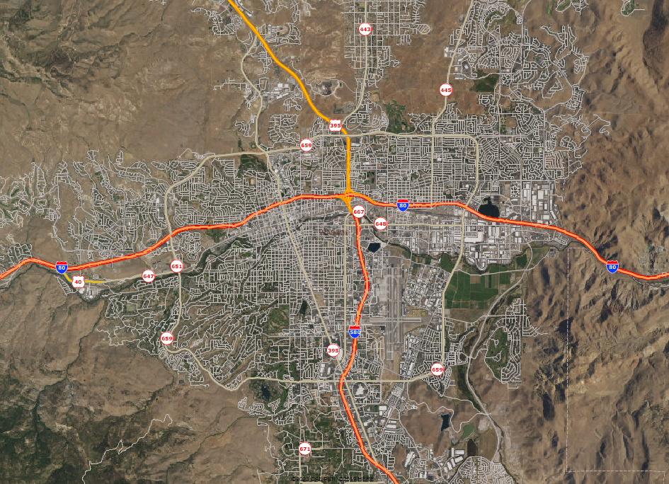

Table of Contents
Model Networks 1
Introduction 1
Roadway Layer 1
Transit Layer 5
TAZ and SE Data 9
Introduction 9
TAZ Boundary Updates 9
Socioeconomic Data Update 10
Accessibility 10
Logsum Accessibilities 11
Population Synthesis 13
Background and Overview 13
Univariate Marginal Distributions 17
Auto Ownership 20
Introduction 20
Model Specification 20
Resident Productions 22
W_HBW 22
W_HBO 25
N_HBSR 27
N_HBO 30
N_HBSCH 33
N_HBSHP 34
Calibration 37
Non-motorized Split 39
W_HBW 39
W_HBO 39
N_HBO 39
N_HBSCH 40
N_HBSHP 40
N_HBSR 40
Time of Day 41
Destination Choice 44
Home-based trip purposes 45
Non-home-based trip purposes 46
Mode Choice 47
W_HBW (home-based work trips along a work tour) 47
N_HBSCH (home-based school trips along a non-work tour) 48
N_HBSHP (home-based shop trip along a non-work tour) 48
N_HBSR (home-based social/recreation trip along a non-work tour) 49
N_HBO (home-based other trip along a non-work tour) 50
W_HBO (home-based other trip along a work tour) 51
Non-Home-Based 52
W_NHBO 52
W_NHBW 55
N_NHBSHP 57
N_NHBO 59
Boosting 62
NHB Time of Day Adjustment 63
University Travel 65
Model Segmentation 65
University Trip Productions 66
University Trip Attractions 67
University Trip Distribution 67
University Mode Choice 67
University Time-of-Day 68
External Travel 69
Introduction 69
External-External (Through) Trips 69
External-Internal / Internal-External (Inbound/Outbound) Trips 70
External Trip Time-of-Day 71
Trucks and Commercial Vehicle Travel 72
Introduction 72
Truck Trip Generation 72
Truck Trip Distribution 72
Truck Time-of-Day 72
Validation 74
Transit 75

Model Networks

Introduction
The highway and transit networks are critical inputs for any travel model. They provide travel time, accessibility, and other impedance information. This documentation uses the term “network” specifically to refer to the machine- readable files (.net and .tnw) TransCAD uses for shortest pathing and assignment. The GIS files that planners and modelers review and edit are referred to as layers. This language is something Caliper is trying to promote to clarify which data component is being referenced.

Roadway Layer
Like the prior version of the model, the new Reno regional model uses a master layer designed to contain all projects stakeholders might consider during transportation plan development (including competing ideas). This allows each scenario layer to be exported from the master with little or no manual editing. Information on using the project management tool is covered in the user guide. The Caliper team also updated the master layer to reflect a 2022/2023 base year, the target year for final model delivery. In other words, if you export a scenario layer without any projects, it will reflect the 2022/2023 road system. This was done by permanently modifying the base attributes of the master layer with any projects scheduled to be complete by the base year date.
The most significant change to the roadway network is the addition of the Fernley area to the east of the prior model boundary. Caliper integrated the added network for the area already created for a special scenario into the master network.
Caliper then reviewed the network and generally found the model’s roadway network coverage to be reasonable and sufficient. However, a small number of additional roadways were identified for inclusion in the new base network:
- Crystal Canyon Blvd.
- Magenta Dr. / Lightning Dr.
- Tracy Rd.
Some alignments were also updated or corrected:
- Copper Canyon Pkwy.
- Lear Blvd.
- Estates Dr.
- Kiley Pkwy.
- Meadowwood Mall Way
- Ridgeview Dr.
- SB 580 Ramps at Meadowood
- Windmill Farms Blvd.
- TRI Connector
Greiger Grade was also extended to the south.
Together with the redesign of the model zones, the centroid connectors were also updated for the network. As the zones increased, the number of centroid connectors did as well, from 1,858 to 2,029. However, they did not increase at the same rate. The increased number of zones allowed for slightly smaller zones on average, and these smaller zones were often more focused on a single loading point. The number of connectors per zone therefore decreased from 2.1 in the old model to 1.7 in the new model. Generally, a lower ratio indicates a better model and a better correspondence between the zones and the network.
Traffic counts were updated to reflect the new 2022/2023 base year. RTC staff provided traffic counts for 2022 and 2023. Daily traffic counts were incorporated into the network from 808 stations. Truck counts were also incorporated but were only available for 73 locations.
The network attributes were also changed to use a more recent master network schema that allows the user to specify additional changes as part of projects, such as changes in median type. For details on the network attributes and use of the master network, see the user’s guide.
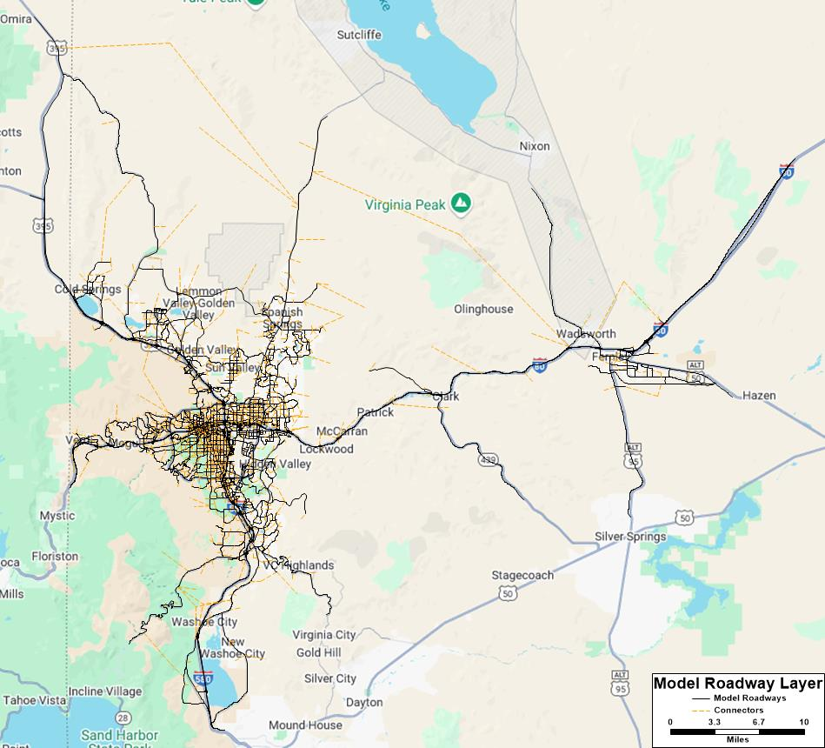
Figure 1. Reno Regional Model Roadway Layer (all)
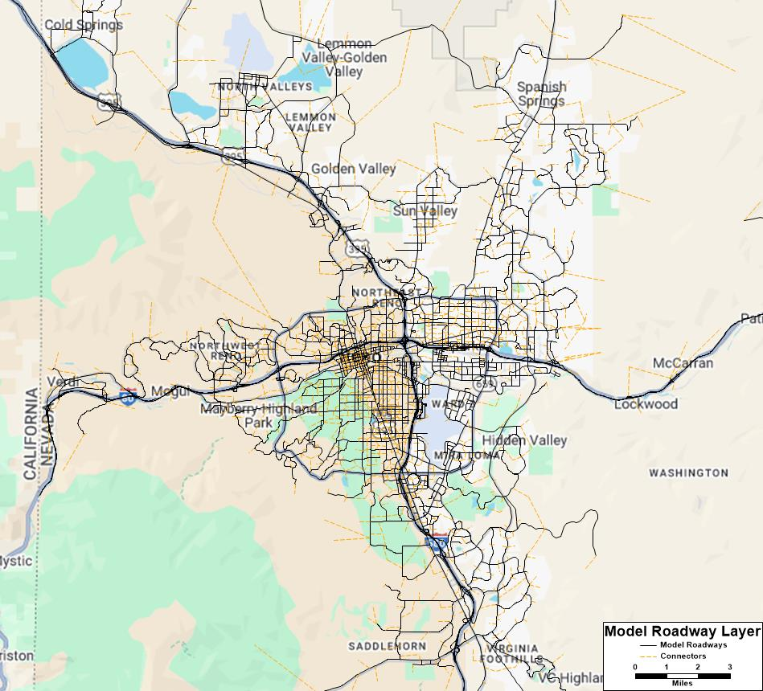
Figure 2. Reno Regional Model Roadway Layer (detail)
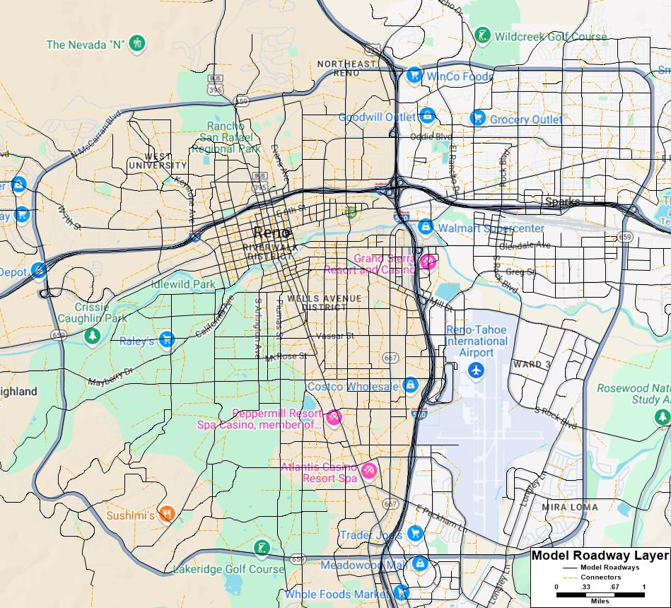
Figure 3. Reno Regional Model Roadway Layer (detail)
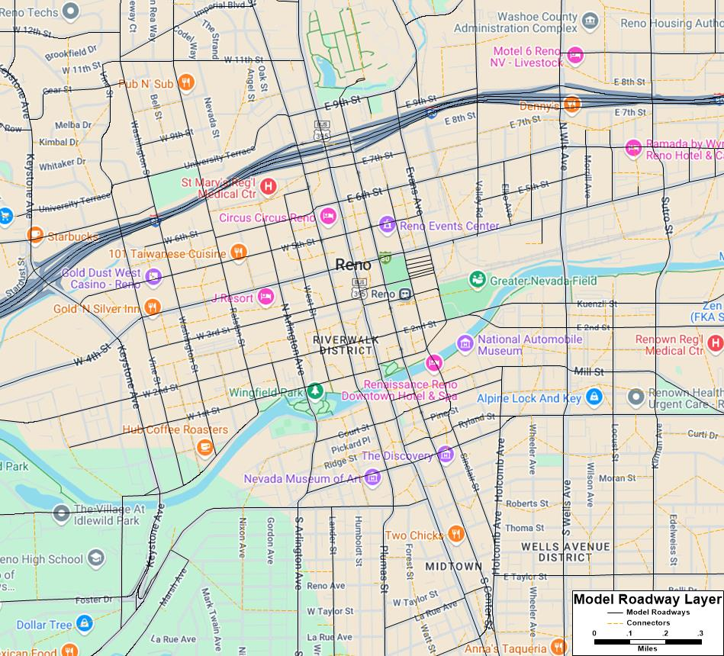
Figure 4. Reno Regional Model Roadway Layer (detail)

Transit Layer
The new Reno regional model adds a master layer for transit routes along with a project manager specially designed to transfer routes accurately between line layers. This enhancement greatly reduces the burden of coding and managing projects between various base and future year scenarios.
More detail on how to use the new tools are included in the user’s guide, but information on the creation of the master route system requires a basic understanding of the tool. In short, the transit project manager finds the shortest path between route stops to reconstruct the route on a new layer. This approach struggles when route stops are not frequent enough to get an accurate path, but the Reno regional model solves this problem using “shape stops”. These are extra stops along the route that are used to improve alignment, but are then removed.
The maps below give a good example of a potential problem when transferring routes between layers using only stop locations only. The shortest path between stops is not always the route a bus takes.
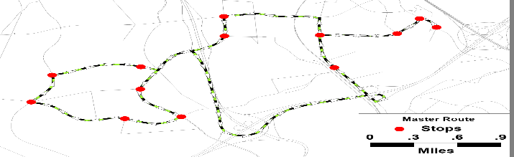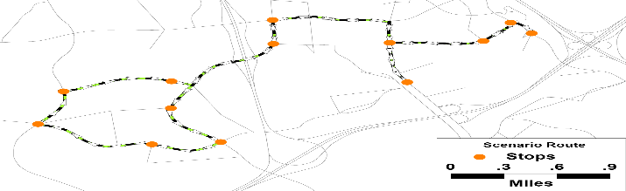
Transferring without shape points
The maps below show how a single shape stop solves the alignment problem while maintaining the correct number of stops.
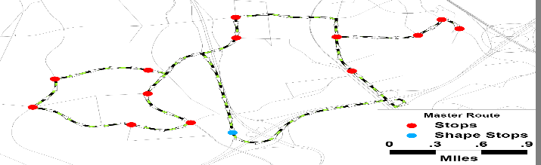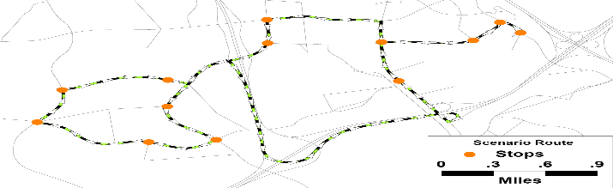
Transferring with shape points
Each time a scenario is created, the transit project manager writes out a file next to the route system detailing how accurate the transfer went. This is achieved by comparing lengths before and after as well as checking for any missed stops. Shape stops can be added until the match is exact, but minor differences in route lengths do not have a measurable impact on model results. The table below provides a sample of the comparison table.
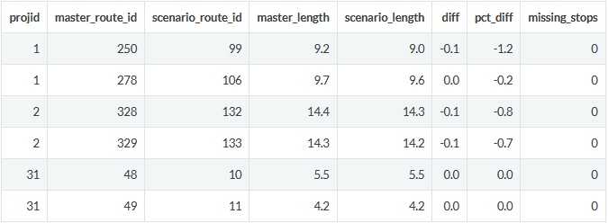

Transit Network Checking
Transit networks are the files TransCAD uses for shortest path, assignment, and other procedures (extension: “tnw”). During the model run, the route system file is converted into many different networks. In the Reno regional model, a separate transit network file is created for each combination of
- Time of Day
  - AM: 7:00 am – 9:00 am
  - MD: 9:00 am – 3:00 pm
  - PM: 3:00 pm – 6:00 pm
  - NT: 6:00 pm – 7:00 am
- Transit Mode
  - Local Bus
  - Express Bus
  - Bus Rapid Transit (if present)
  - Commuter Rail (if present)
  - Light Rail (if present)
- Access Mode
  - Walk
  - Kiss-and-Ride (aka drop off)
  - Park-and-Ride
Creating separate files facilitates the critical step of auditing the networks. The model translates the route, stop, link, and node layers into a transit network, and it is important to make sure the networks are behaving appropriately. In the Reno regional model, for example, the AM and PM PNR networks behave differently. In the AM, where trips are primarily from home to destinations like work, drive access works in the PA direction:
- Drive to a PNR lot
- Walk to the bus access stop
- Ride the bus to the egress stop
- Walk to the final destination
In the PM network, trips are primarily back to home. For this reason, the drive access flow is reversed.
- Walk to the access stop
- Ride the bus to the egress stop
- Walk to the PNR lot
- Drive home
TransCAD can handle this behavior, but it is always important to check that the model code is setup correctly. Separate network files allowed the two maps below to be created quickly to confirm proper behavior.
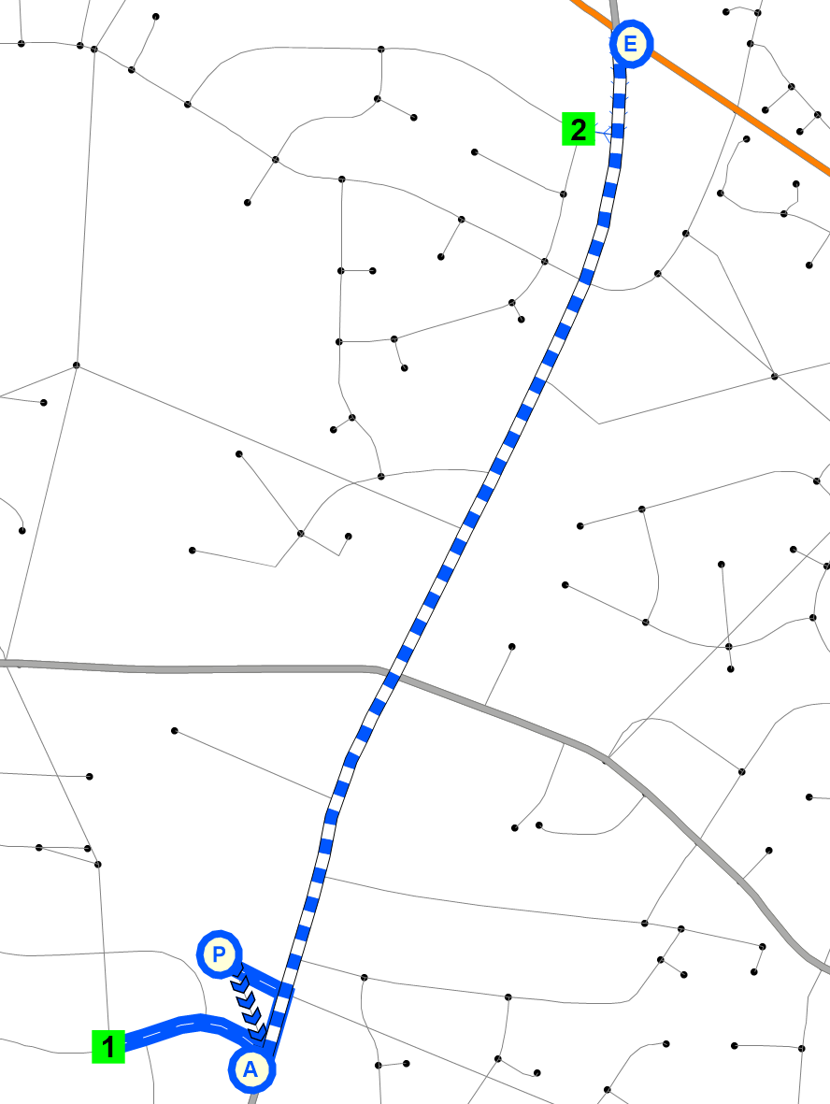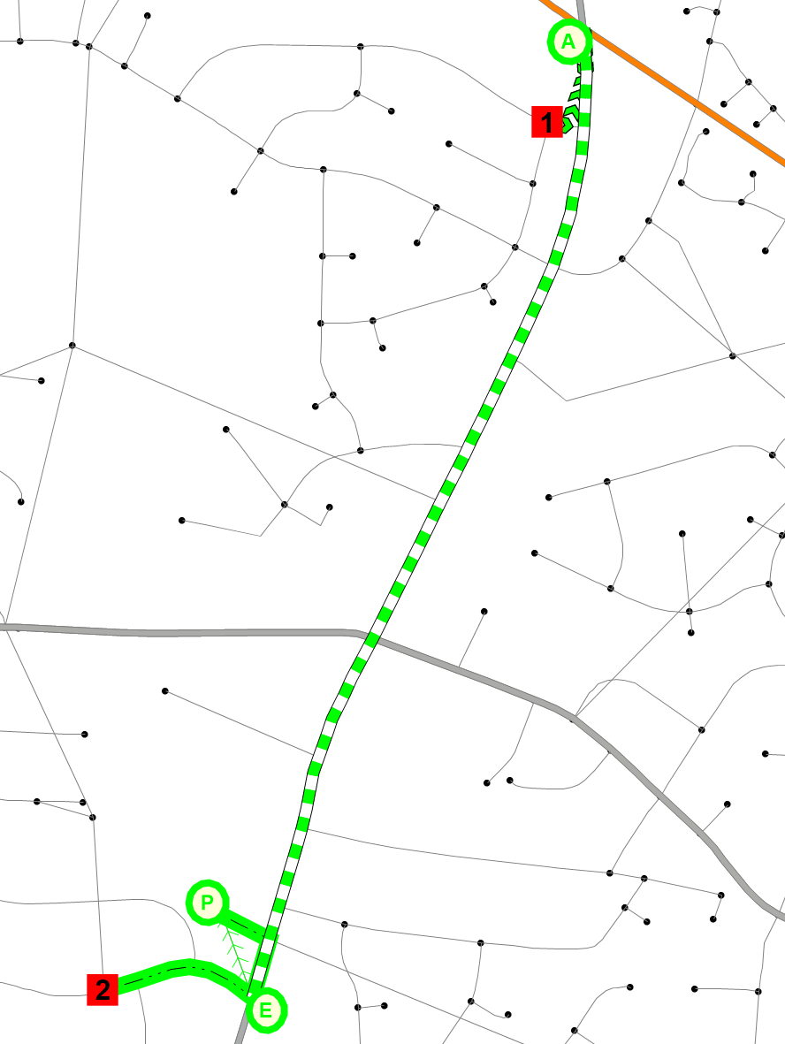
Figure 5. AM vs PM transit skims

TAZ and SE Data

Introduction
In the Reno regional model, as in most travel models, the geographic area being analyzed is split into many smaller spatial units or zones. These TAZs (which stands for travel, transportation, or traffic analysis zones) have several uses, including: storing information about the people and places in each zone, serving as origins and destinations of trips, and calculating travel times between (and within) zones.

TAZ Boundary Updates
As with the network, the first major modification of the zone system was the addition of zones to the east to cover the Fernley area. Beyond this, Caliper undertook an extensive review of the Reno regional TAZ system. Factors considered in the review included:
- Avoiding concavities in the model area boundary
  - The overall model study area boundary now is largely convex. Small concanvities remain, but no large ones remain which would likely cause travel originating from and destined to model zones to travel outside the study area before returning to it.
- Minimizing zones with overly large population (>2,000) or employment (>2,500)
  - It is desirous to minimize the number of these zones as they are apt to cause overloading of the network.
  - Zones with population over 2,000 decreased from 33 in the old model to 16 in the new model.
  - Zones with population employment over actually increased from 16 to 19, but this was due to the growth of several large employers such as hospitals and casinos which should not be split.
- Separating homogenous residential areas from homogenous commercial areas
  - It is desirous to make residential neighborhoods distinct origins/destinations from commercial developments particularly if they access the network at different locations.
  - Comparing the employment of the zone to the sum of employment and households, the percentage of zones which were homogenous (<10% or >90% employment) increased from 42% to 58%.
- Maximizing consistency with census block and block group boundaries
  - It is advantageous in the estimation of socio-economic attributes for zones if the zones conform to census boundaries. Conformity with property boundaries did not allow perfect conformity with census boundaries as well, but the number of zones violating census boundaries was reduced.
- Elimination of unnecessary small zones
  - Additional unneeded zones simply add to the model’s runtime (which is a function of the number of zones squared). Therefore, small zones with little population or employment (or prospect thereof) were combined to created larger zones.
The prior model included 896 zones. Eighteen zones were added for Fernley in the special scenario version of the old model bringing the total to 914 zones. As a result of the review, there was a net increase of 250 zones to bring the total in the new model to 1,064.

Socioeconomic Data Update
The socioeconomic data for all model scenario years was stored as attributes on the TAZ layer in the previous version of the model. In the new model, the TAZ layer contains only basic, scenario-independent attributes while scenario-specific socioeconomic data is contained in scenario-specific .bin tables. The socioeconomic variables used in the new model are also different than those in the prior model. Both models use the number of households, the population in households, and the number of households by household size. The new model uses the median household income rather than a breakout of the number of low-, medium-, and high-income households. The new model also uses the percent of workers (versus people) in households in each zone; the prior model did not take the number of workers as a direct input. The new model also uses the percent children and the percent seniors in place of the population by age category though these are very similar and related variables. On the economic side, the new model takes the number of employees by the 25 two-digit NAICS categories in place of the six custom industry categories in the old model. The actual socioeconomic data was prepared by Truckee Meadows Regional Planning Agency. Please contact Damien Kerwin or Jeremy Smith for more information on the preparation of the socioeconomic data.

Accessibility
Network travel times and zonal socioeconomic variables can be combined to calculate accessibility variables. Accessibility is a measure of a traveler’s ability to reach locations where they can engage in necessary and desired activities.
Accessibility can be measured in various ways and different measures are useful for different purposes. It is not uncommon for planners to use accessibility measures such as the number of jobs accessible within a 30-minute commute because measures such as this are readily understandable. However, metrics like this are not as good for analysis and modeling because they can exhibit significant discontinuities or “cliff-effects” where, for example, a large employer is 31 versus 29 minutes away. For this reason, in travel models, more continuous but sometimes less intuitive accessibility measures are used.
Another way accessibility can be measured, more similarly to the way it is commonly measured in models is the average cost (usually in terms of minutes) of a trip from a given location, perhaps for a particular purpose, by a particular mode, and/or at a particular time of day.
Accessibilities, thought of as the average or expected cost of a trip, affect many aspects of travel behavior and are therefore included in many components of behaviorally realistic advanced travel models. The average cost of trips (in miles) from a residence location clearly affects auto ownership because, for instance if most activity destinations can be reached within a mile, a car is not necessary. Residents of dense, highly-accessible areas also can afford to make more trips, because their trips are shorter on average, and so they can accomplish more trips in the same travel time budget. Thus, downtown dwellers make more, shorter trips than the regional average and rural residents make fewer, but longer trips. Although some older trip-based models partially reflected this through the stratification of trip generation rates by area type, the use of continuous accessibility variables in generation models is clearly preferable both in terms of statistical support and model response properties. To fully and accurately reflect this fundamental difference between travel patterns by residents of different parts of the region, accessibility must also be incorporated in destination choice. The accessibility of the home location scales residents’ willingness to travel (sensitivity to travel time) because when a person chooses their residence location, they are also choosing how far they are generally willing to travel. The accessibility of destinations is also a factor in destination choice because it measures the cost of an additional (non-home-based) trip from that location.
A number of accessibility measures are therefore used in the Reno regional model to measure these various effects of accessibility on travel behavior and patterns.

Logsum Accessibilities
Logsums can be considered as a weighted average accessibility. While logsums are most often discussed in relation to mode choice and destination choice models, the logsums used for these accessibility measures are based on a simpler gravity formulation as a proxy and to avoid endogeneity problems from simultaneously estimating destination choice models including logsums of those same and other destination choice models.

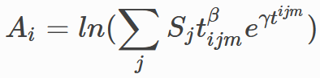
Where:
A_{i} : Accessibility of zone i
t_{ijm} : Travel time between zone i and j by mode m
S_{j} : Attractions in zone j (size term)
Accessibility logsums are useful for many steps of the model. One example is the non-home-based production models. A non-home-based walk trip is more likely to occur in areas with high walk accessibility, and they are less likely in area with poor access.
The Reno regional model makes use of some generic functions for calculating multiple accessibility variables, based loosely on NCHRP 365, etc. The table below presents three of the most widely used as examples. The first four rows detail which skims, cores, and decay parameters to use. The remaining rows show the attraction rates for the size variable calculation.
Param | access_general_sov | access_nearby_sov | access_transit
skim | sov | sov | transit
core | FFTime | FFTime | Total Time
b | -0.93 | -2.05 | -2.05
c | -0.09 | -0.06 | -0.06
HH | 1.9 | 0.5 | 1.9
K12 | 1.5 | 0 | 1.5
College | 5.7 | 0 | 5.7
StudGQ_UNR | 5.7 | 0 | 5.7
Retail | 18.7 | 4.1 | 18.7
Service_RateLow | 5.6 | 1.2 | 5.6
Service_RateHigh | 5.6 | 1.2 | 5.6
Office | 3 | 0.5 | 3
Industry | 3 | 0.5 | 3

Population Synthesis

Background and Overview
Creating a synthetic population, or in other words, enumerating a complete set of households and persons (with key attributes) for a modeling region is a necessary first step for the application of advanced travel models such as hybrid trip-based models and Activity Based Models (ABM).
The synthesized household and person characteristics reflect the distribution of key variables in the study region and match observed marginal distributions at an aggregate level.
Having access to detailed person and household characteristics in the model opens the door for model estimation to include a range of variables that define trip and travel making behavior. Even for traditional trip-based models, development of a synthetic population and household database can help generate various cross-tabulations at desired geographic levels that may not be available otherwise.
For the Reno regional model, a population synthesis forms the core basis for applying a state-of-the-art hybrid travel demand model. The aim of the synthesis is focused on matching both household and person marginals at the Traffic Analysis Zone (TAZ) level. Another crucial requirement is a solution that is practical to apply and runs in minutes without sacrificing accuracy of the results. To that end, the updated population synthesis procedure in TransCAD 10.0 is employed.
This documentation briefly summarizes the basic idea of population synthesis, some of the advancements made in recent years and points the reader to published literature for additional details. It also details the creation of disaggregate curves, which convert aggregate zonal data into targets for the synthesis process. The technical approach for population synthesis in the Reno regional model is briefly illustrated, following details regarding the application. Finally, the results of the application are demonstrated.

Basic Idea (Simple Iterative Proportional Fitting / IPF)
The basic idea of population synthesis is best illustrated by Figure 1. In simple forms of population synthesis, there are two inputs: disaggregate household (HH) and person seed tables and HH marginals summarizing the distribution of key characteristics of HH at some aggregate level of geography.
The seed data tables consist of a sample of household (HH) and person records, typically obtained from a survey of the study region, and tagged to a high-level geography such as Public Use Microdata Areas (PUMAs). Public Use Microdata Sample (PUMS) data from the American Community Survey (ACS) typically forms this seed, although this sample can be enhanced by incorporating data from a travel survey and reweighing the combined records.
Various aggregate marginals, typically ACS marginals at the census block or block group level in the base year or sometimes at higher levels of geography for future years provide control totals that the synthesized databases must match. It is also a well-accepted practice to fit curves using the census marginal distributions, which can then be applied to generate marginals at a TAZ level for example. These TAZs are usually smaller than census block groups but larger than census blocks.
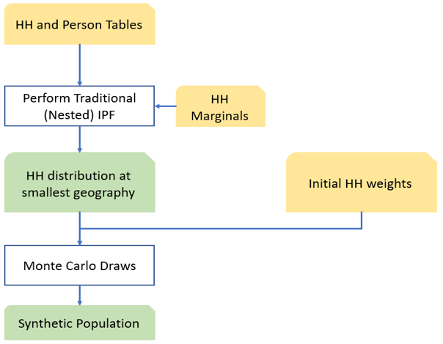
Figure 1 Simple population synthesis process flow diagram
An Iterative Proportional Fitting (IPF) step then estimates the number of each type of household (identified in the seed) to be generated for each of the smallest geographic entities. This is achieved by identifying the number of households of each type that will add up to various household marginals. This is best illustrated for a single block group using the schematic in Figure 2. In this example, the two classifications of interest are HH by Size and HH by Number of Vehicles. The row and column marginals highlighted in yellow are the input control totals and the goal of the process is to fill in the cells of the matrix (i.e. the values TS1_V0 etc.) such that the row and column totals are respected. The value TS1_V0 represents the number of single person, zero car HHs that need to be synthesized for this block group.
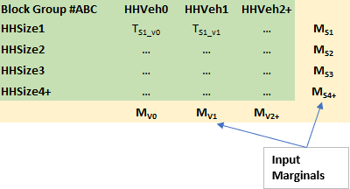
Figure 2 IPF
The term “Nested” in Figure 1 indicates that the household marginals may themselves be specified at different (but nested) geographies: for example, the vehicle ownership marginals may be at the traffic analysis zone (TAZ) level while the income marginals may be at the level of Census blocks or block groups. Nested synthesis will drill all the marginals down to a common geography (usually the smallest/finest among all input geographies.
Finally, for each smallest geographic entity, the required number of households of each type determined by IPF are sampled or drawn from the surveyed (seed) households using externally supplied (initial) weights (generally based on the survey sampling). The selected households are accumulated in a HH output file, and all persons living within each sampled household are automatically copied into a person output file. Together, the HH and person files comprise the synthetic population once the sampling is complete.
The most important drawback of this process is the lack of control on person marginals. Since the algorithm only controls for household variables, the obtained distribution of person attributes in any given zone is largely a lottery. There is no guarantee that the chosen households will yield, for instance, the correct distribution of age, gender, etc., in the synthetic population. This can have adverse effects from a modeling application perspective, for example if the distributions of working-age persons, students or seniors are incorrect.

Person Marginals and Iterative Proportional Updating (IPU)
The Iterative Proportional Updating (IPU) process (Xe et al, 2009) has been proposed and applied (most notably in PopGen) as a way of matching person marginals while essentially retaining the simplicity of the IPF framework. In this approach, before sampling households for a particular geographic entity (zone) using the initial weights in the seed, these sampling weights are first adjusted (or raked) to explicitly match both household and person marginals for the zone. In this process, note that the same seed household(s) may be weighted differently for different zones, which adds precision compared to the use of a priori weights supplied externally. Further, this household re-weighting may be applied at a different (usually more aggregate) geography than that used for simulating the population.
Figure 3 shows the general schematic of the IPU enhancement over IPF. Note the additional inserted steps which creates the loop. As mentioned earlier, the HH seed weights are adjusted for each zone to match HH and person marginals for that zone.
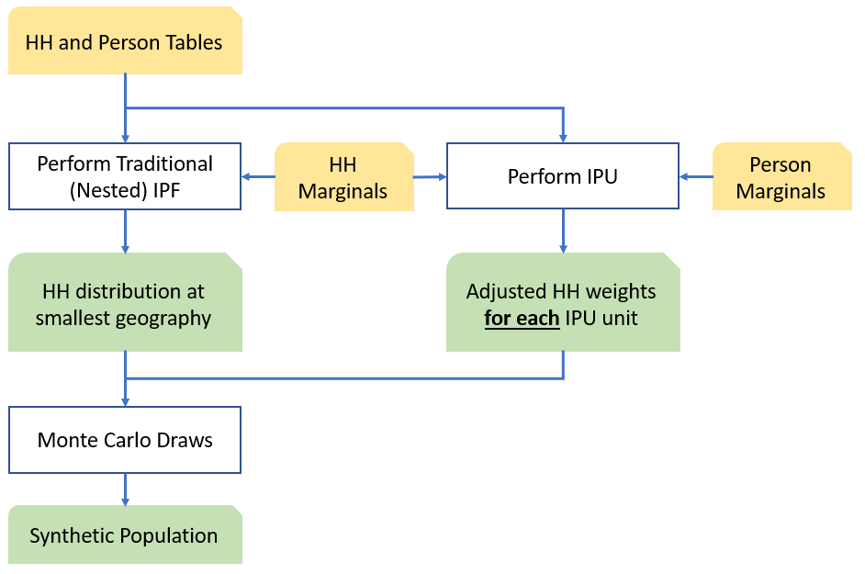
Figure 3: Population Synthesis with IPU
The originally published IPU method in the literature was implemented in the PopGen software. In this original IPU algorithm, two separate IPFs are run, one on the HH marginals and one on the person marginals. The results of the second IPF on the person marginals are used to populate detailed person-level columns in the incidence table that specify the full, joint distribution of person attributes. So, if there are multiple marginals to match such as HHs by Size (1,2,3,4+), number of vehicles (0,1,2,3+) and number of workers (1,2,3,4+) and Persons by Age (assume 5 categories) and Gender, then the incidence table has 64 HH columns, one for each combination of size, vehicles and workers and 10 person columns, one for each age category and gender combination. Since only one-dimensional marginals are typically known, the marginal values in the incidence tables come from the IPF run and the second IPF must be performed on the person characteristics to populate the person columns.
This version of IPU has several drawbacks. One, the process is slow, especially if there are a lot of marginals and the process can take hours. Second, the solution introduces a couple of other issues that must be dealt with and these issues have garnered significant attention in literature. One of these issues is a zero-cell problem, where the seed data is stretched thin and certain combinations may not be present in the seed. The second issue is a zero-marginal problem, but this can be solved by replacing the zero in the marginal row with epsilon values. There are several techniques to address these issues, which have been implemented in PopGen, but addressing these issues adds further runtime.
Therefore, a different variant of IPU was developed for and implemented in TransCAD. For want of minimizing these issues and at the behest of maintaining fast run times, only the one-dimensional marginals are used to form the incidence table. Thus, in the hypothetical example, the incidence table has 12 HH columns (as opposed to 64) and 7 person columns (as opposed to 10). The enhanced TransCAD IPU method has been applied successfully for the Las Vegas RTC model, the California Central Coast ABM model, as well as the Triangle Regional Model in North Carolina. In all cases, not only was the match to the one-dimensional marginals (especially the persons) very close but the joint distribution observed from the synthesis was also very reasonable. These applications take a fraction of time compared to that reported on similar sized problems with the original IPU method or optimization methods. For more details on TransCAD’s IPU algorithm, see Balakrishna, R., S. Sundaram and J. Lam. “An Enhanced and Efficient Population Synthesis Approach to Support Advanced Travel Demand Models.” Presented at the 99th TRB Annual Meeting.

Other Techniques
Several optimization methods have also been published in the literature. For a general literature review, see Ramadan and Sisiopiku, 2019. While these methods might tackle certain issues of the IPU approach, these methods tend to be customized. Owing to the nonlinear and non-convex nature of the resulting formulation, the performance can be problem dependent and can result in long run times, local optima, and sensitivity to the scale of the objective function.

Univariate Marginal Distributions
The Reno regional model v1.0 borrows its one-dimensional marginal distributions from the Triangle Regional Model (Raleigh/Durham, NC). These distributions describe the population in each zone based on the limited demographic variables forecast for each zone, typically averages. The distribution of households by household size is provided by the user as an input to the Reno regional model, but distributions for households by income group and number of workers must be developed by the model based on the simple zonal average (income and worker) data provided. In other words, the model starts by determining the number of single worker, two worker, three worker, etc., households in each zone based on the average workers per household in the zone.
Stratification curves simply encode information on the extent to which, for example, a zone with 2.5 workers-per-household on average will have a high percentage of 2- and 3+-worker households and a zone with an average of 1.5 persons-per- household will have more 1- and 2-worker households.
In the Reno region, the marginal distribution stratification curves used are:
- Income
  - Low: $0 - $24,999
  - Medium-Low: $25,000 - $74,999
  - Medium-High: $75,000 - $149,999
  - High: $150,000 and above
- Workers (0-3+)

Workers
The chart below shows the stratification curves used in the Reno regional model to break out households by number of workers based on the average number of workers per household in the zone.
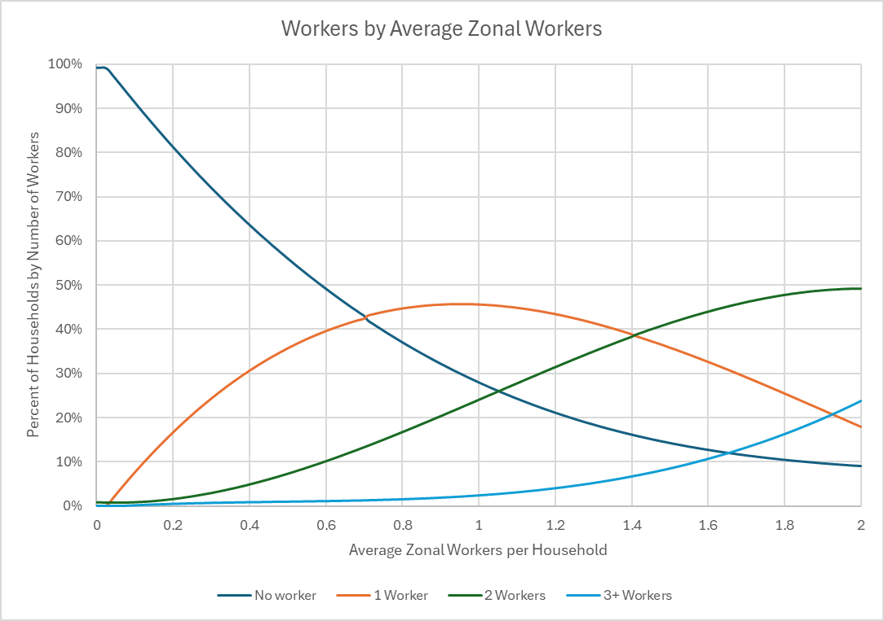

Income
The chart below shows the stratification curves used in the Reno regional model to break out households by income group based on the ratio of the average zonal income per household in the zone to the average income per household in the Reno region. The model uses four income groups defined as follows:
- Low Income: Less than $25,000 per household per year
- Medium-Low Income: $25,000 – 75,000 per household per year
- Medium-High Income: $75,000 – 150,000 per household per year
- High Income: Greater than $150,000 per household per year
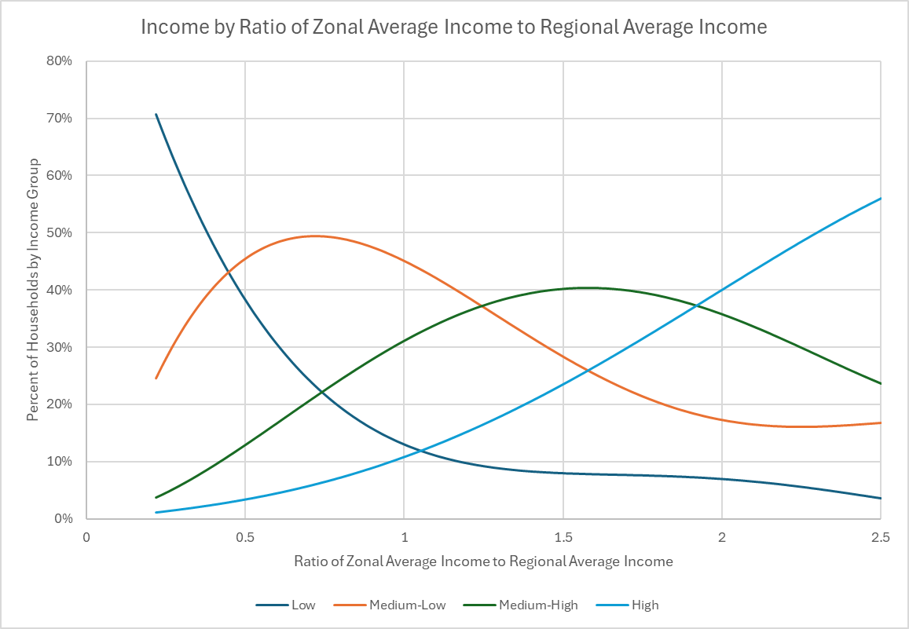

Auto Ownership

Introduction
Auto ownership is a long-term decision that directly impacts daily mode choice. The choice is influenced by household factors like income and number of workers, but also by where people choose to live. The auto ownership model allows the Reno regional model to be sensitive to these factors and respond to changes in the future.
Auto ownership is predicted using a discrete choice model. For more details on general model form, click here.

Model Specification
The auto ownership model in the Reno was borrowed from the Triangle Regional Model (Raleigh/Durham NC). The model makes use of variables from the synthetic population and zonal accessibility to make predictions. The model structure is a simple multinomial logistic (MNL) regression model with five alternatives:
- 0 Vehicles
- 1 Vehicle
- 2 Vehicles
- 3 Vehicles
- 4+ Vehicles
The table below shows the utility terms and model coefficients.
 | No Vehicles | 1 Vehicle | 2 Vehicles | 3 Vehicles | 4+ Vehicles
Constant | 0 | 4.79 | 2.49 | 1.80 | 0.74
Workers |  | 0.72 | 3.33 | 4.34 | 5.34
Non-working Adults |  | 0.00 | 2.08 | 0.00 | 0.00
Seniors |  | 0.08 | 0.08 | 2.83 | 3.65
Walk Accessibility |  | -0.37 | -0.62 | -0.62 | -0.72
Transit Accessibility |  | -0.09 | -0.15 | -0.20 | -0.20
Nearby Accessibility |  | -0.38 | -0.53 | -0.83 | -1.14
Walkability |  | -0.53 | -0.53 | -0.53 | -0.53
Low Income HHs |  | -0.56 | -1.80 | -1.84 | -3.20
Med-Low Income HHs |  | 1.60 | 1.60 | 1.60 | 1.60
Med-Hi Income HHs |  | 1.82 | 2.61 | 2.75 | 2.75
High Income HHs |  | 2.23 | 3.70 | 4.15 | 4.51
The coefficients all have the right sign and the relative sizes are intuitive. For example, higher-income households are more likely to own more cars. One particularly encouraging result of this model is that households with strong walk and transit accessibility are less likely to own a vehicle and even less likely to own multiple vehicles. This adds another dimension of model sensitivity to transit investments. New transit routes will affect long-term household decisions about auto ownership, which further influence their daily transportation decisions.
Looking in more detail, the trend for coefficients across alternatives is also intuitive. Large numbers of workers in a household have a small positive impact on the utility of owning 1 auto, but a large impact on owning 2 or more. High income households are more likely to own more vehicles.

Resident Productions
Productions are predicted at the person level using decision trees for the machine learning stack. Compared to traditional cross-classification matrices, they use the survey samples more efficiently and can consider more variables. While state of the art decision trees methods including bagging and boosting achieve slightly higher prediction accuracy, they are opaque. The models below are simple trees that are easy to understand and perform nearly as well.
Trip purposes in the model are first stratified by the tour type they occur on (work vs non-work), and are laid out below:
- Trips on work tours
  - Home-based work (W_HBW)
  - Home-based other (W_HBO)
- Trips on non-work tours
  - Home-based social/recreational (N_HBSR)
  - Home-based other (N_HBO)
  - Home-based school (N_HBSCH)
  - Home-based shop (N_HBSHP)
For most purposes, separate decision trees were estimated for each market segment. The market segments are:
- Zero vehicle (v0)
- Vehicle insufficient (vi)
- Vehicle sufficient (vs)

W_HBW
The home-based work purpose is sensitive to the usual variables like employment status of the person, their age, and their households income per capita (income divided by size). The models are also sensitive to various measure of accessibility:
- Transit accessibility (t_access)
- General/auto accessibility (g_access)
- Walk accessibility (w_access)

v0
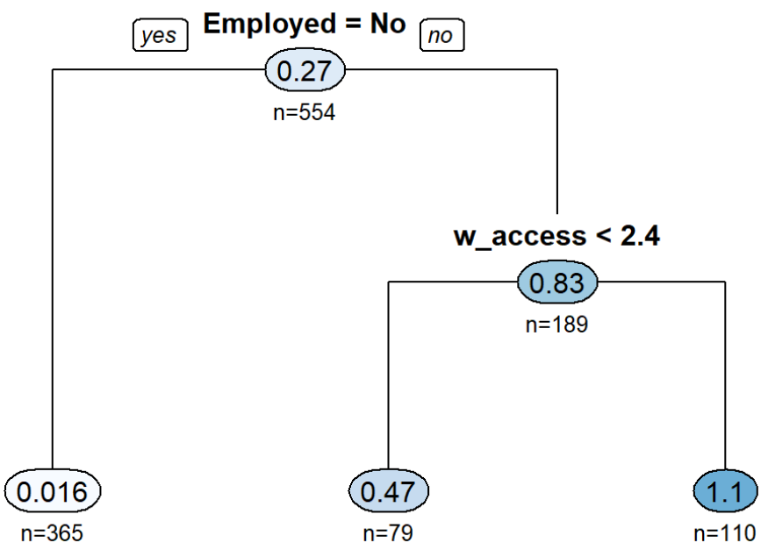

vi
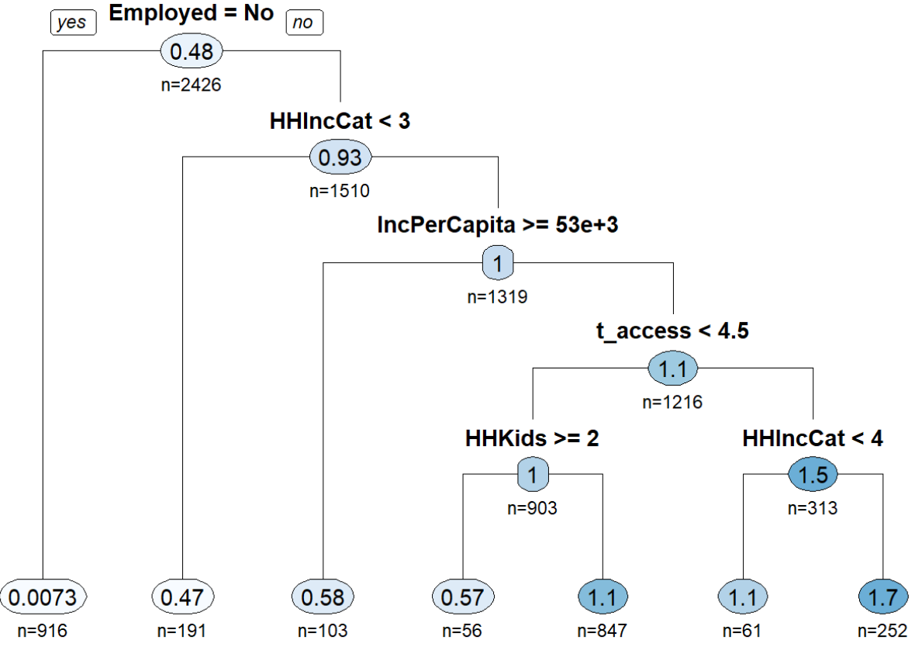

vs
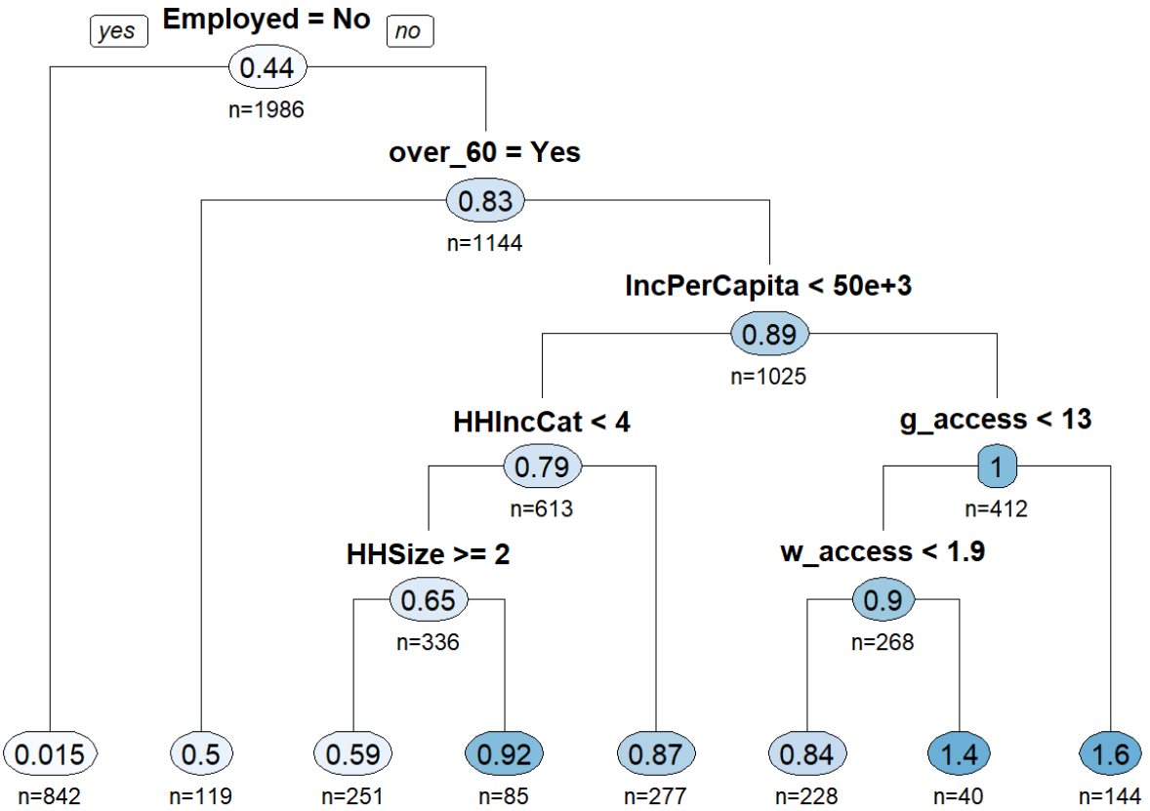

W_HBO
This purpose is sensitive to variables like the presence of seniors, gender, size, income, and age.

v0
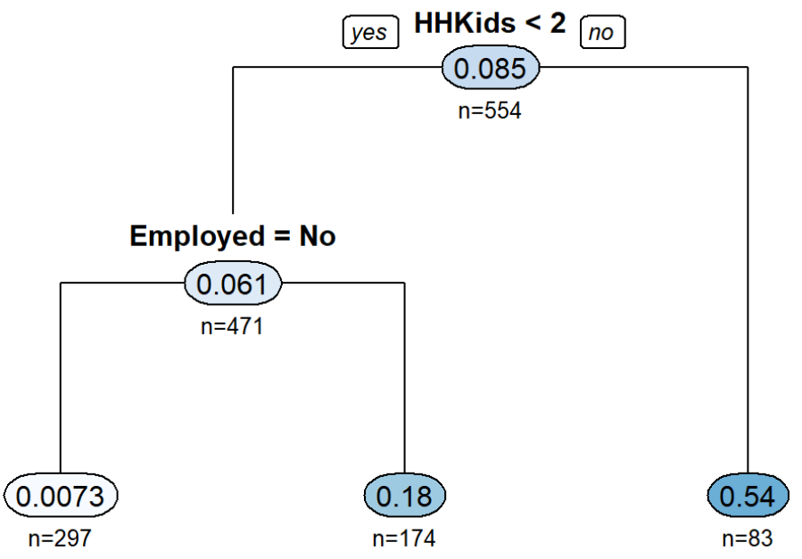

vi
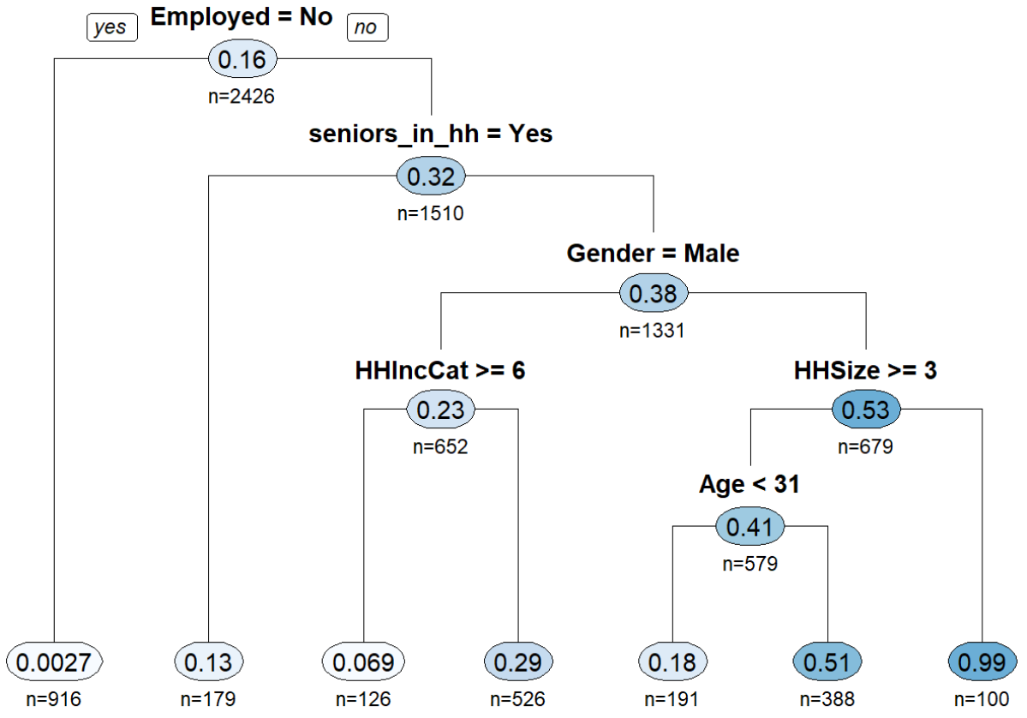

vs
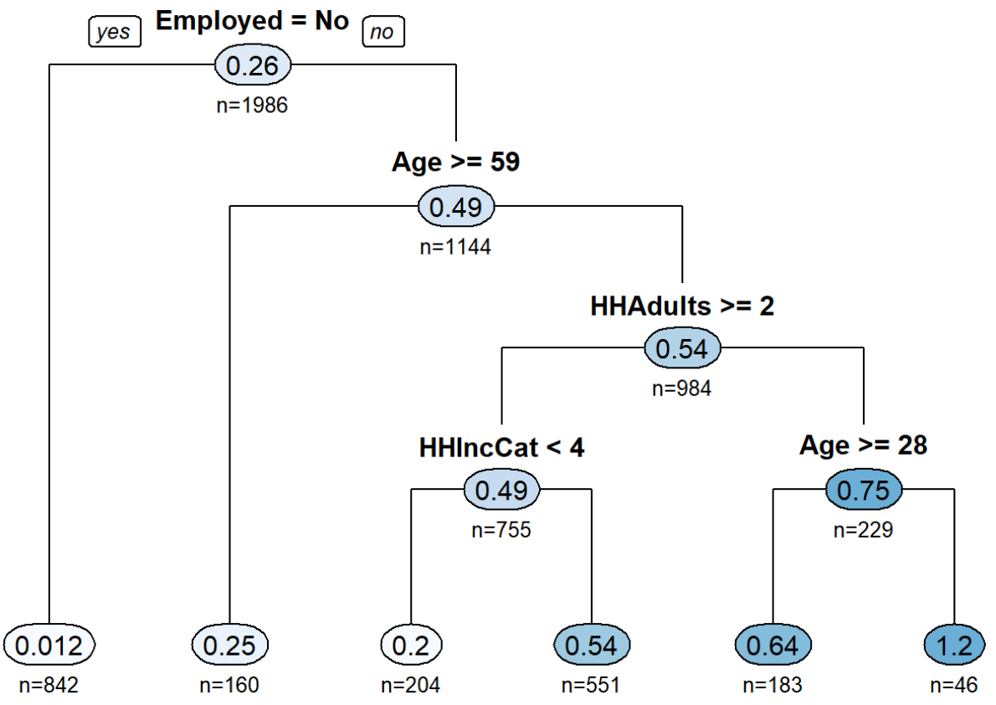

N_HBSR
The social/recreational models are sensitive to variables like accessibility, employment, per capita income, age, and presence of children.

v0
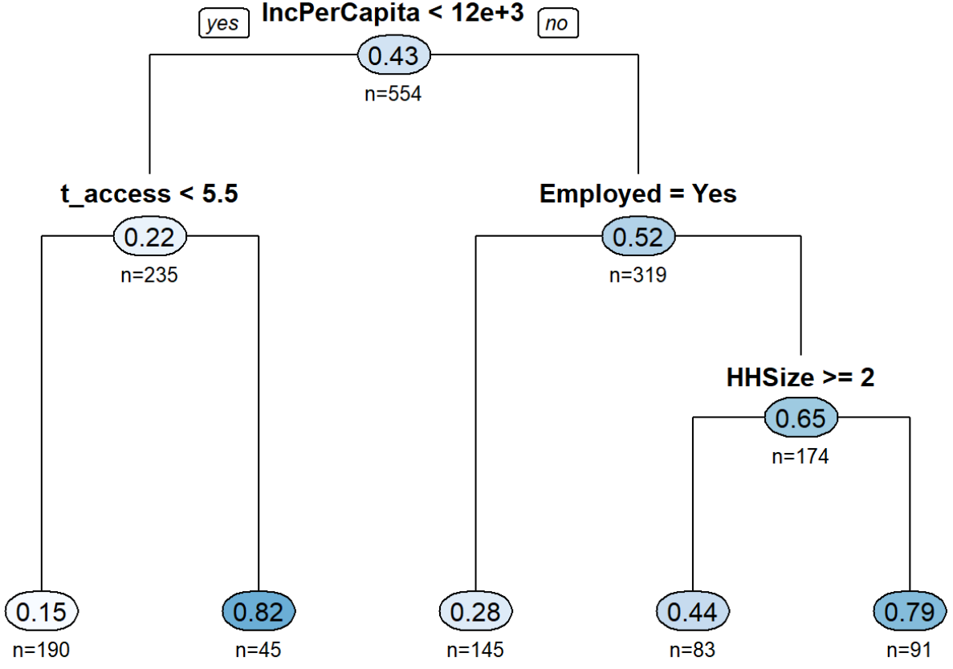

vi
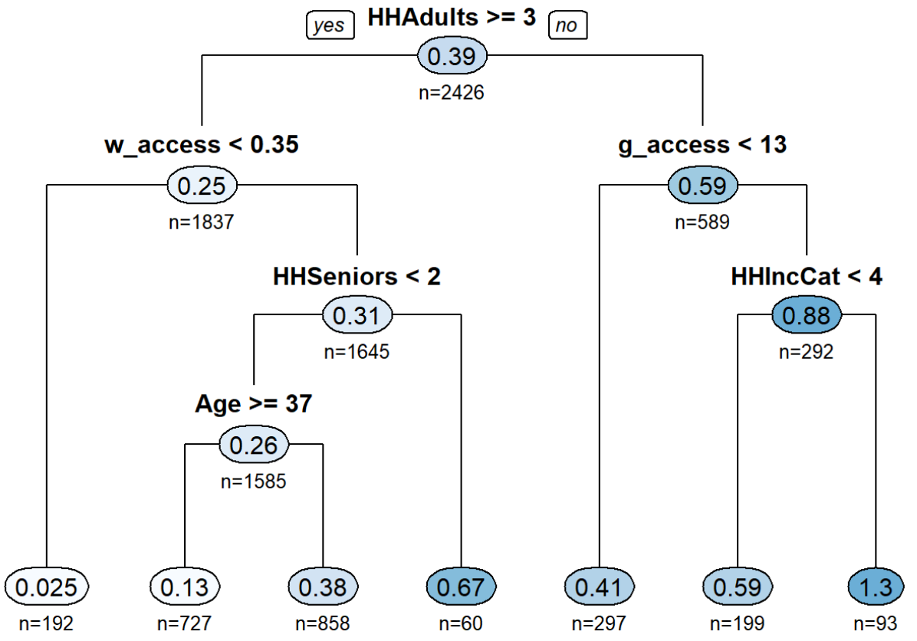

vs
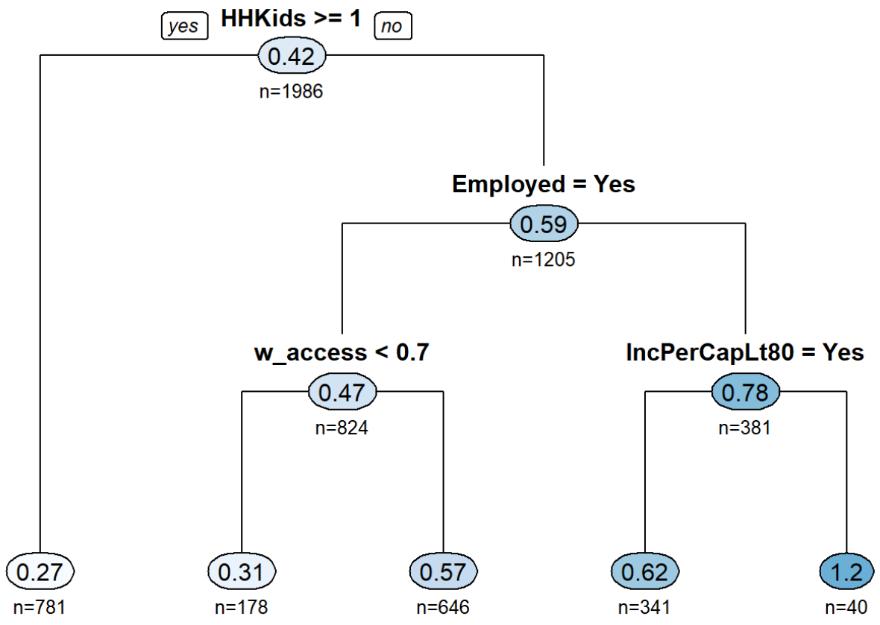

N_HBO
These models are sensitive to variables like age, gender, accessibility, and employment status.

v0
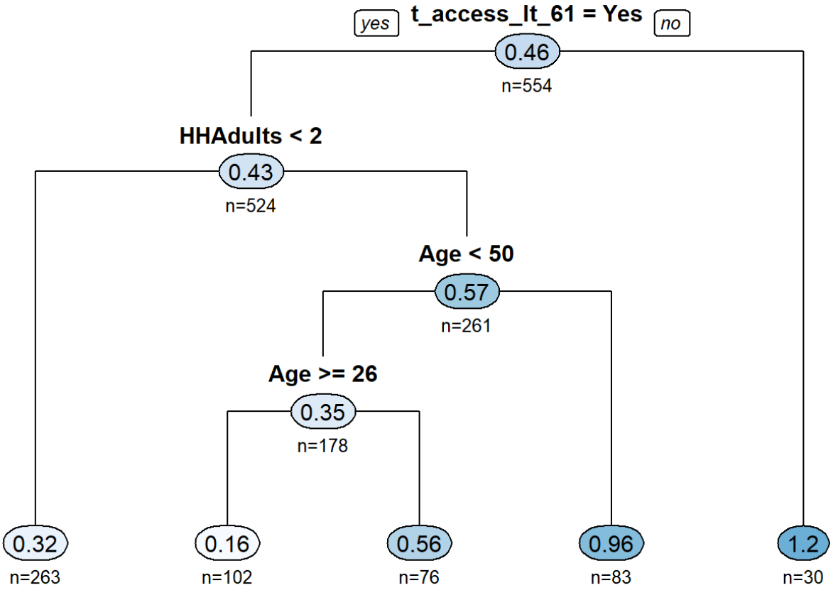

vi
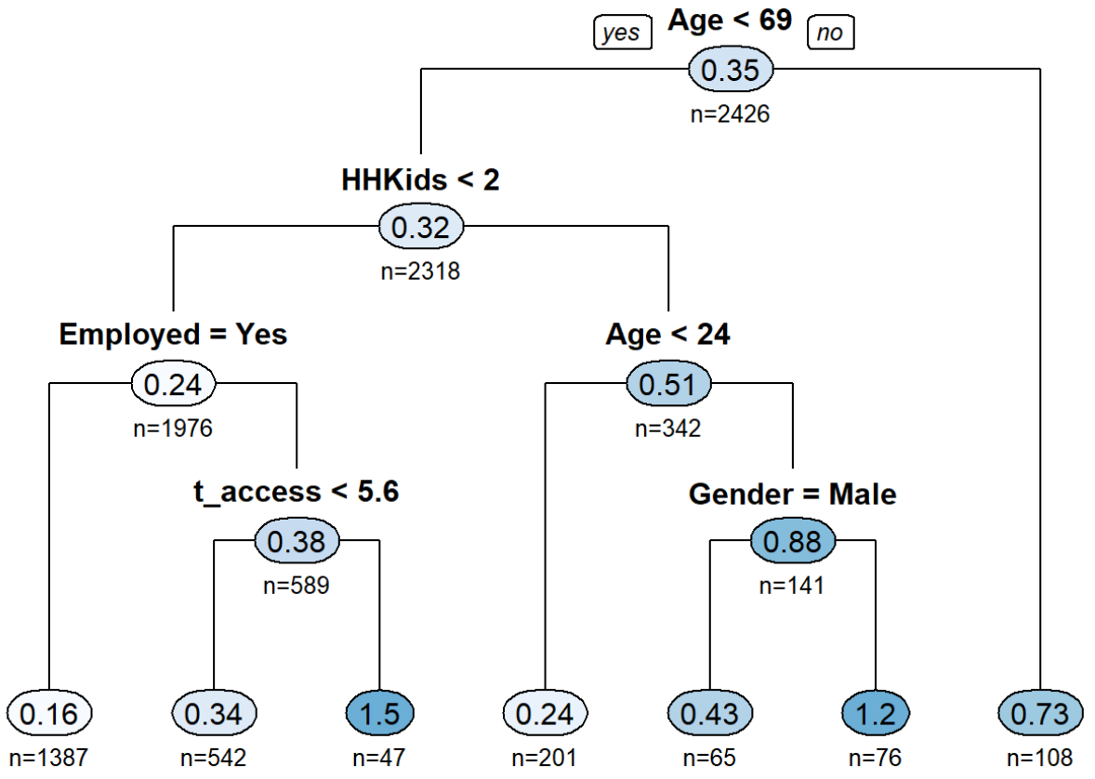

vs
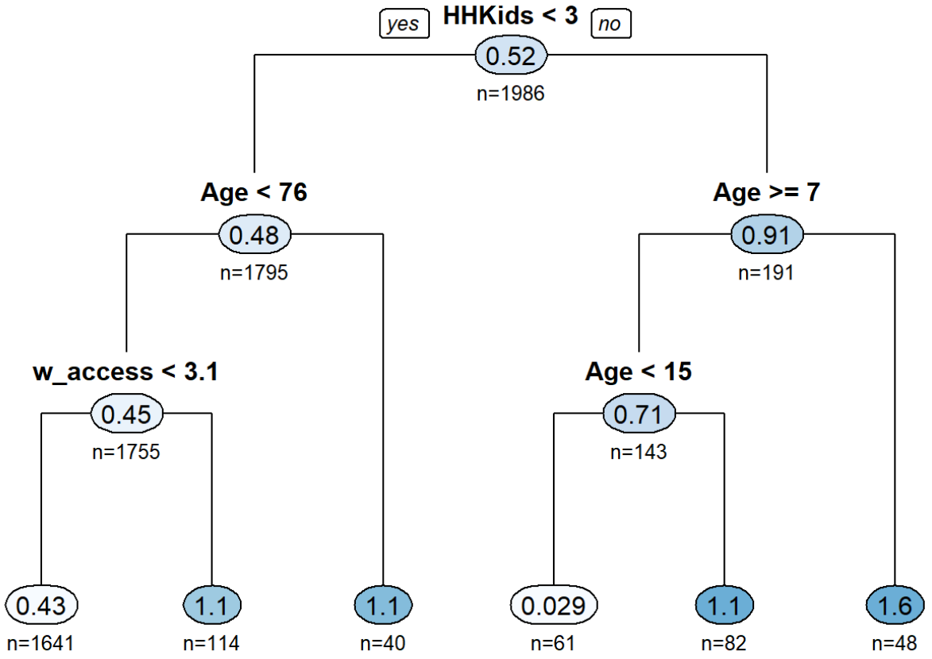

N_HBSCH
The most important predictor for these model is the age of the person, but other factors like accessibility and income do influence the number of school trips made. This purpose is not stratified by market segment.
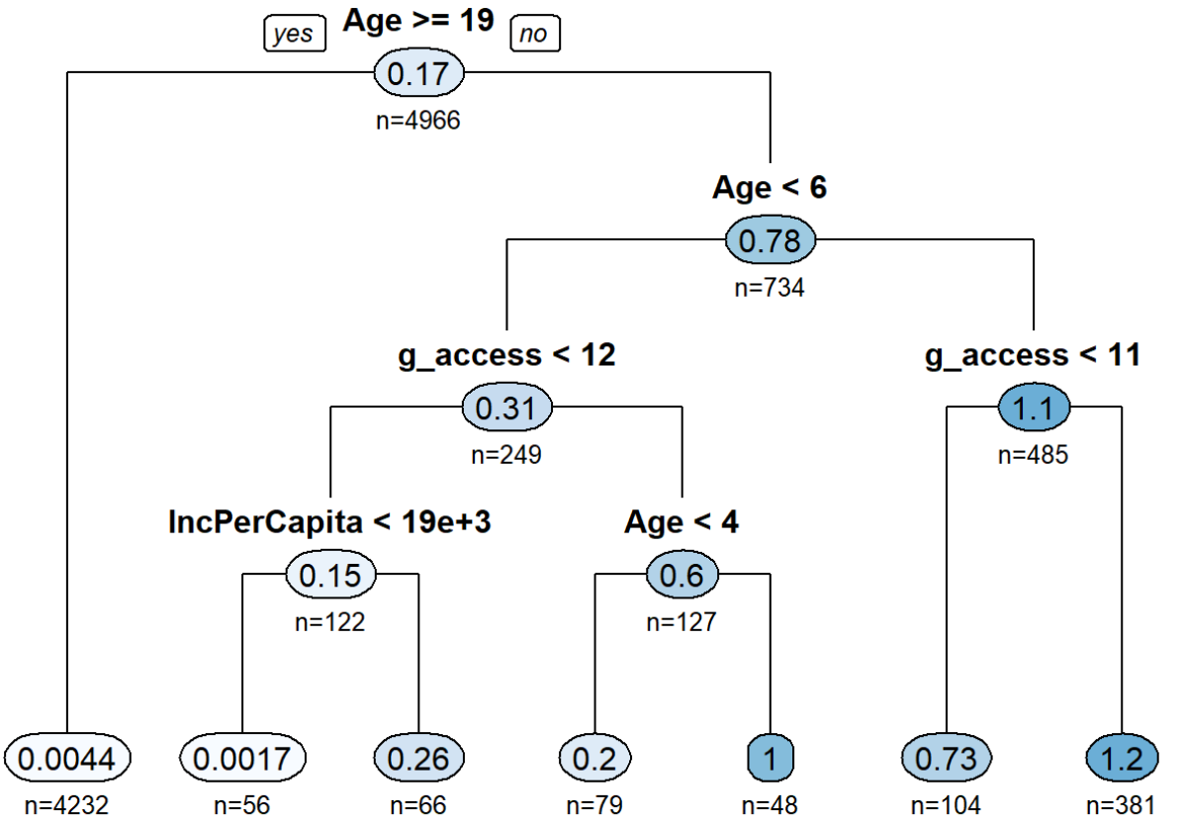

N_HBSHP
Shopping trips are influenced by employment status, accessibility, age, income, along with the presence of kids and seniors.

v0
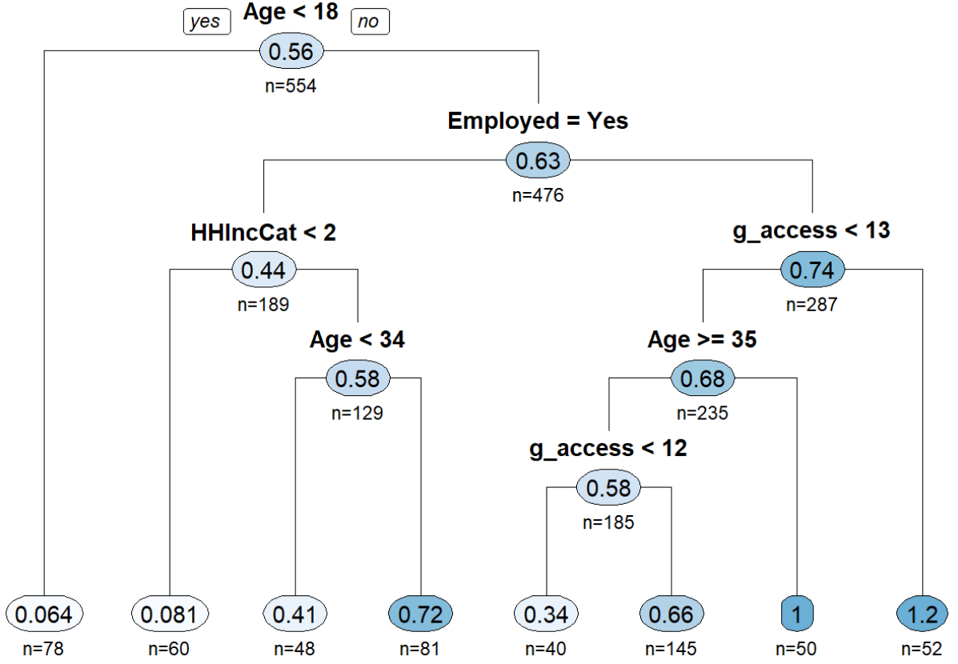

vi
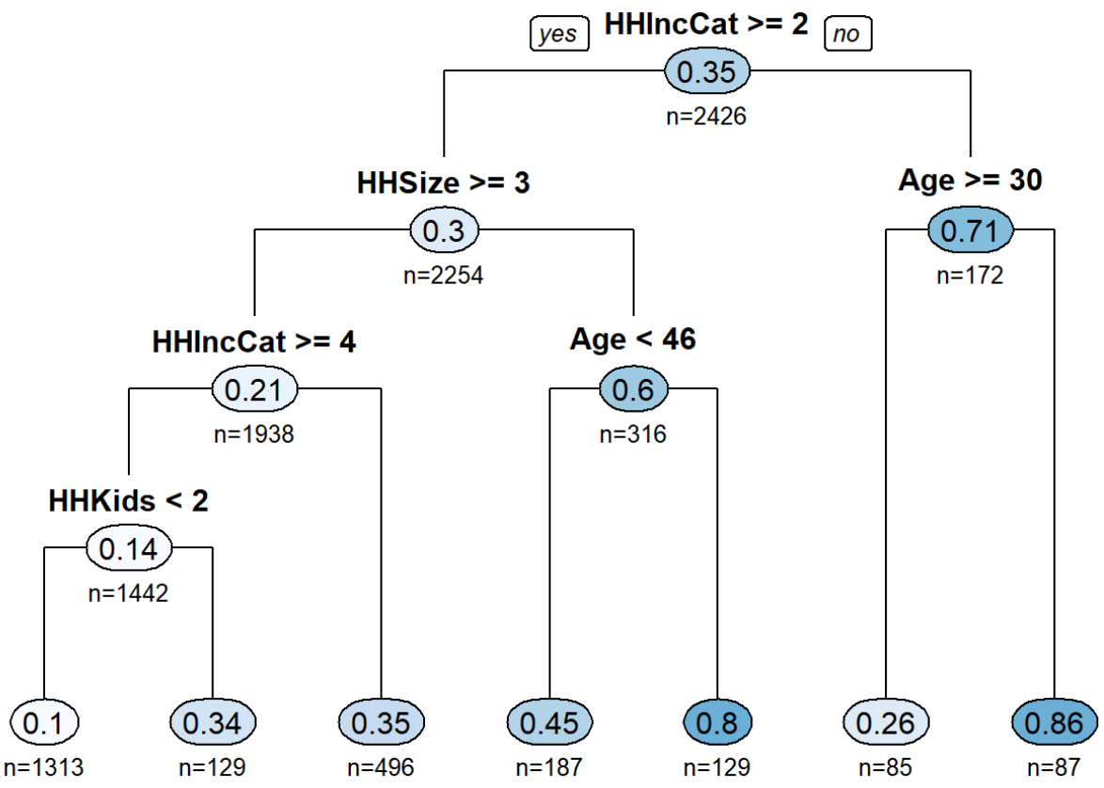

vs
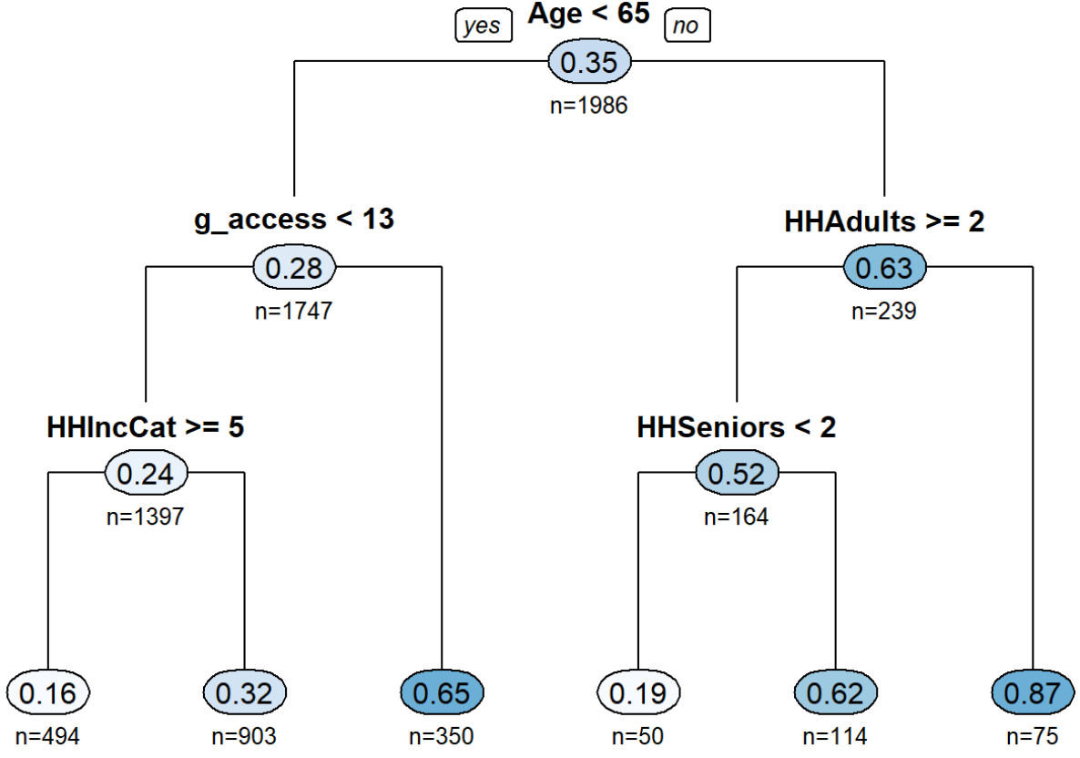

Calibration
Calibrating the production rates is done to ensure that the final model is producing the same number of trips per person on average as the survey. One complicating factor in this comparison is that the survey and model socio-economic data have different total populations.
- Survey: 476,187
- Model: 523,542
As a consequence, the survey trip totals are increased by 1.1 and then compared to model results. The table below shows the production model results compared back to the total trips in the survey (factored up). While some purposes are higher or lower than the survey, the model does a good job of predicing total trips even before calibration.
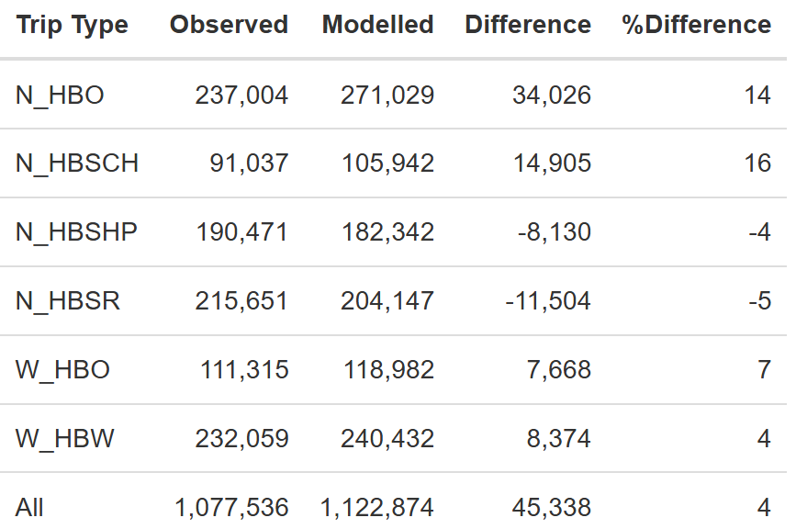
The calibration factors below are the ratio of the observed to modeled trips. These are applied by trip type and auto sufficiency segment to ensure total trip making matches the survey (based on trip weight).
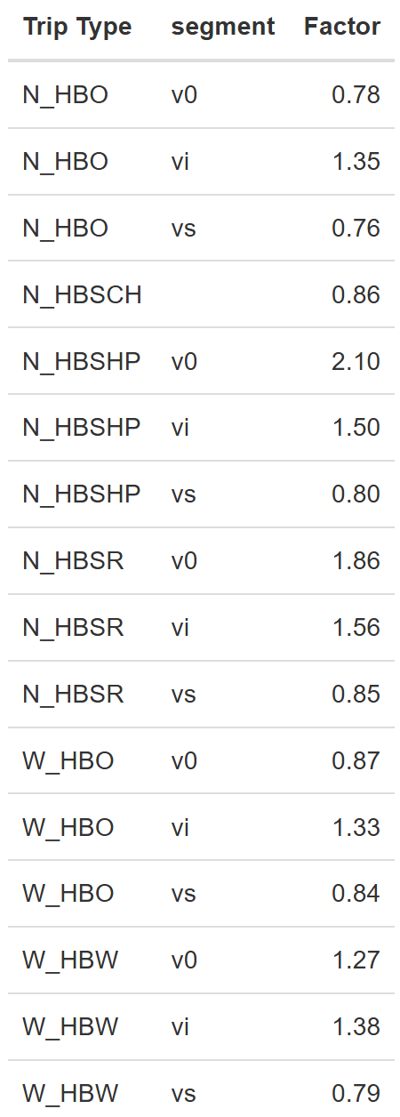

Non-motorized Split
After resident productions are estimated, the model removes non-motorized trips (bike and walk) using a binary logit model. For each trip purpose, the estimated coefficients are shown along with the adjusted rho-squared and the calibration constant applied to match survey shares of non-motorized trips.

W_HBW
Variable | Coefficient | t-Statistic | Alternatives
 |  |  | moto | non-moto
HH Kids | 0.066 | 2.8107 |  | X
HH Adults | 0.047 | -1.3555 |  | X
Vehicle per Adult | 0.254 | -11.657 |  | X
Walk Access | 0.073 | 1.2553 |  | X
Constant | 0.270 | -3.7151 |  | X
Rho^2 | 0.66
Calibration Constant | 0.60 |  |  | X

W_HBO
Variable | Coefficient | t-Statistic | Alternatives
 |  |  | moto | non-moto
HH Kids | -0.290 | -2.213 |  | X
HH Adults | 0.149 | 2.2412 |  | X
Vehicle per Adult | -3.807 | -7.922 |  | X
Walk Access | 0.093 | 0.7413 |  | X
Constant | -1.156 | -2.528 |  | X
Rho^2 | 0.69
Calibration Constant | 1.03 |  |  | X

N_HBO
Variable | Coefficient | t-Statistic | Alternatives
 |  |  | moto | non-moto
Vehicle per Adult | -0.490 | -2.9348 |  | X
Walk Access | 0.470 | 5.9330 |  | X
Senior | -0.942 | -2.5293 |  | X
Constant | -2.786 | -11.476 |  | X
Rho^2 | 0.56
Calibration Constant | 0.31 |  |  | X

N_HBSCH
Variable | Coefficient | t-Statistic | Alternatives
 |  |  | moto | non-moto
HH Kids | 0.320 | 4.4758 |  | X
HH Adults | -0.527 | -3.325 |  | X
Vehicle per Adult | -1.060 | -3.888 |  | X
Walk Access | 0.609 | 4.2519 |  | X
Constant | -1.843 | -3.051 |  | X
Rho^2 | 0.48
Calibration Constant | 0.19 |  |  | X

N_HBSHP
Variable | Coefficient | t-Statistic | Alternatives
 |  |  | moto | non-moto
Vehicle per Adult | -3.054 | -10.159 |  | X
Walk Access | 0.253 | 2.6459 |  | X
Senior | -0.661 | -2.0033 |  | X
Constant | -1.315 | -5.0432 |  | X
Rho^2 | 0.65
Calibration Constant | 0.66 |  |  | X

N_HBSR
Variable | Coefficient | t-Statistic | Alternatives
 |  |  | moto | non-moto
HH Kids | 0.369 | 6.6602 |  | X
HH Adults | -0.117 | -1.481 |  | X
Vehicle per Adult | -2.378 | -9.723 |  | X
Walk Access | 0.453 | 4.8056 |  | X
Senior | -0.612 | -1.515
Constant | -1.816 | -5.326 |  | X
Rho^2 | 0.63
Calibration Constant | 0.46 |  |  | X

Time of Day
Peak period determination is based on an analysis of the trips in motion throughout the day. First, the day is broken up into 15-minute increments. A trip from the household survey is said to be “in motion” if any portion of the trip occurs within the 15-minute bin. As a result, a single trip can be counted in multiple bins. Determining the peak period considers the distribution of all trips as well as the distribution of trips on work tours individually. The chart below shows these two distributions, which look as expected with the AM peak being shorter and more condensed than the PM.
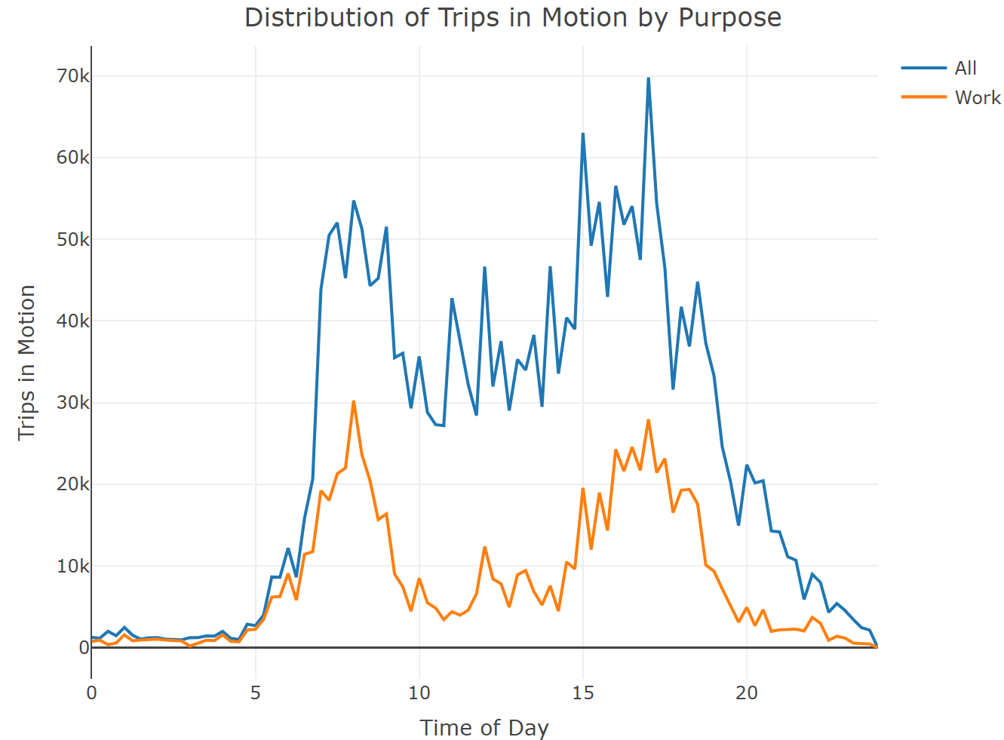
The next step is to determine the peak hour for all trips and those on work tours. In the tables below, the AM and PM peak hours by type are presented. At a minimum, the AM and PM peak periods should contain the respective peak hour for work trips and all trips.
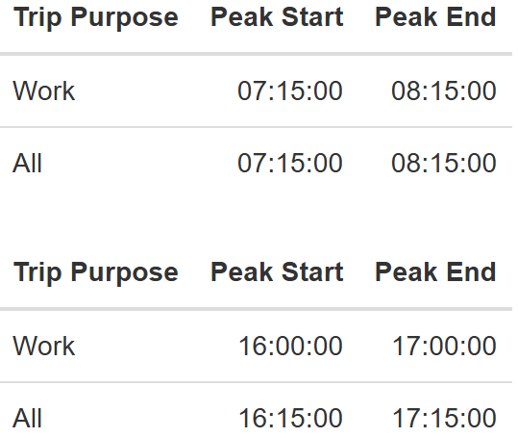

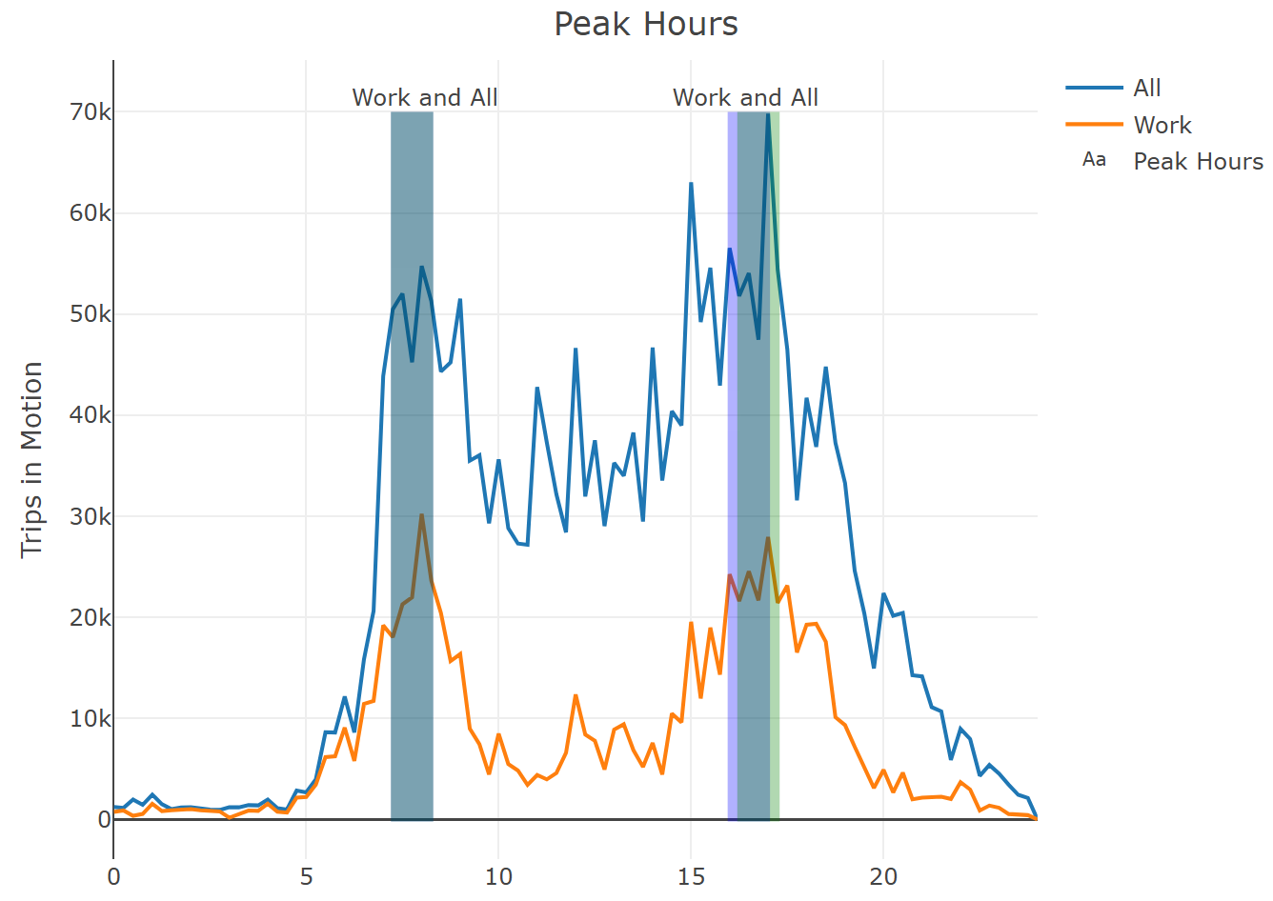

Based on the trips in motion profile, there are four distinct periods of the day. AM and PM peaks have the highest intensity of trip making, followed by mid-day, with the overnight period containing the fewest trips in motion. Boundaries for these periods are defined such that the variance of trips in motion within periods is smallest while variance between periods is largest.
The final period definitions are shown in the table below including the mid-day (MD) period. The remaining hours of the day are captured in the night (NT) period. In the chart, the final period is represented by the gray rectangle.
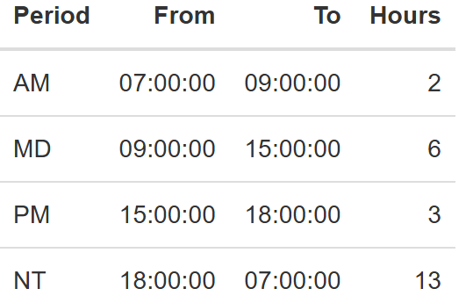
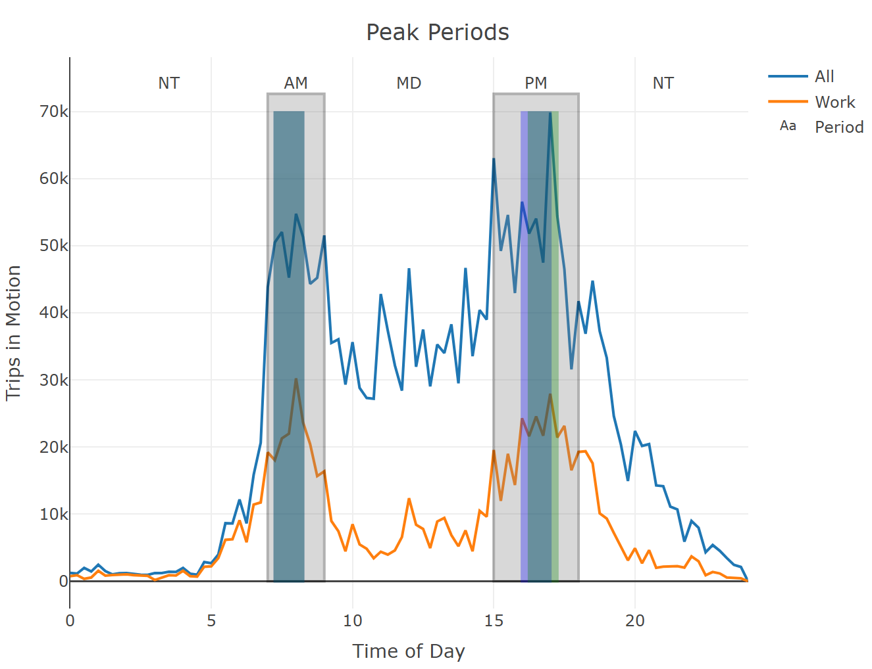

Destination Choice
Locations in the Reno travel demand model are nested into a two-stage behavioral process: a cluster (spatially aggregated from the zones) is first chosen, followed by a second choice of a zone from within the selected cluster. This process has many advantages, such as enhanced accuracy on a dimension that influences other critical outcomes such as mode choice.
The fifteen clusters are illustrated in the map below:
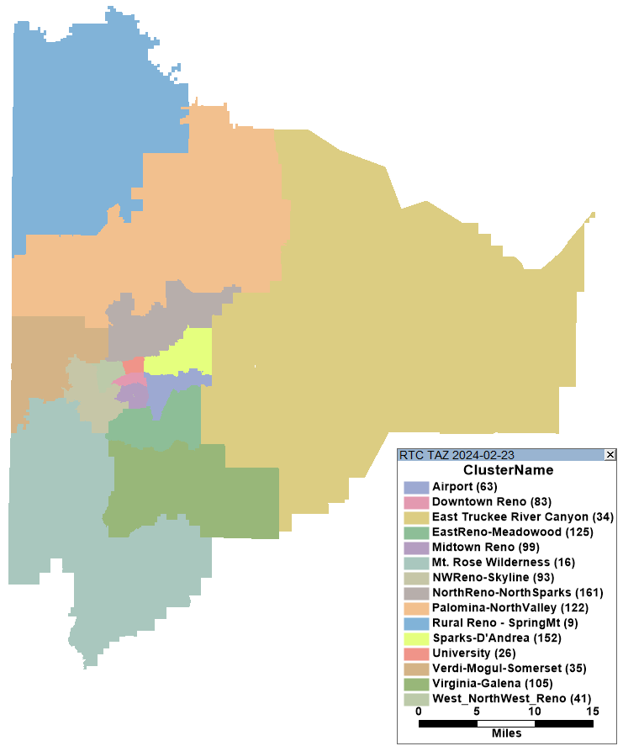

Home-based trip purposes
The destination choice specifications for the six home-based trip purposes are split across two tables. The first table below contains the cluster constants, intra-cluster constants, and other variables related to geography, level of service and accessibility. T-stats greater than 2 or smaller than -2 suggest high confidence in a variable’s role in the model; however, it is OK to keep some variables with weaker t-stats to keep logical sensitivities in the model. In addition, the signs of coefficients all look reasonable. For example, the coefficient on time should always be negative (which it is). This indicates that destinations further away are less desirable.
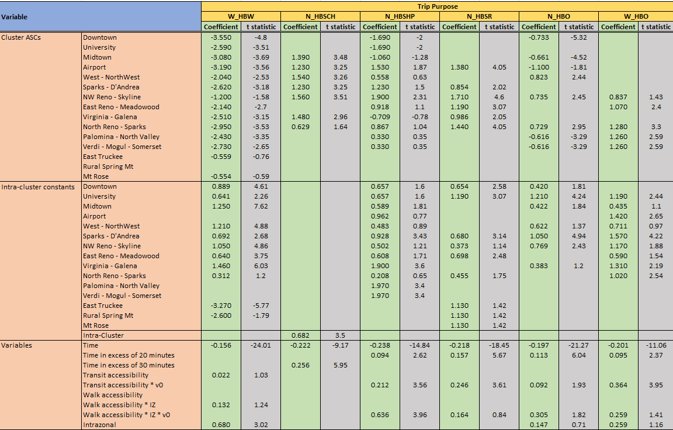
Many intra-cluster effects are significant, which indicate a propensity to remain relatively close to home for these trip purposes. A further intra-zonal effect is in play for the ‘work’ and ‘other’ purposes. Time has the expected negative impact on location choice, though its influence attenuates beyond a certain threshold for many purposes. Destinations with higher transit and walk accessibilities are more attractive to the zero-car segment and on intrazonal trips.
The second table (shown below) contains the effects related to the nests and the double constraint effects via the size terms:
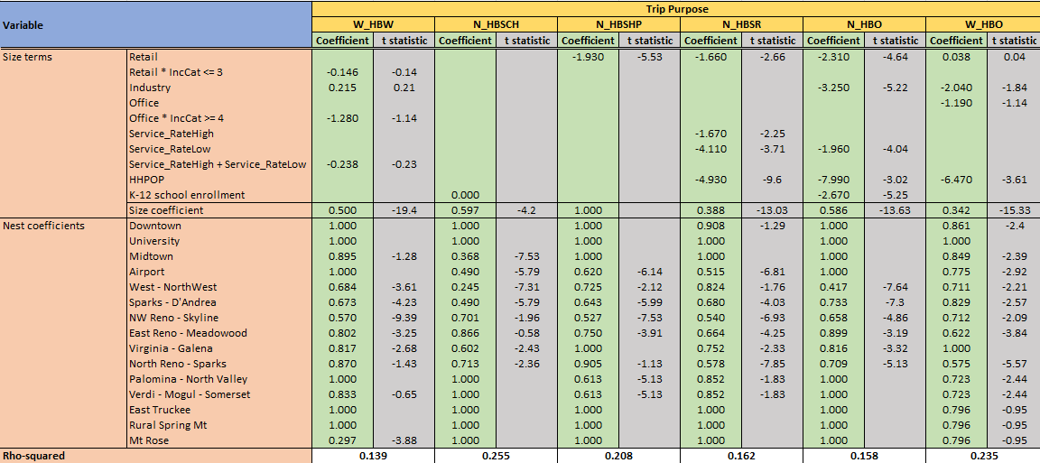
Numerous nest coefficients were statistically different from the default of 1.0, which validates the nested approach to destination choice. Various employment totals, population numbers, and school enrollments ensure that the model sends the right number of trips to each zone.

Non-home-based trip purposes
Destinations for the mode-specific non-home-based trip purposes are determined via multinomial choice models with the following specifications:
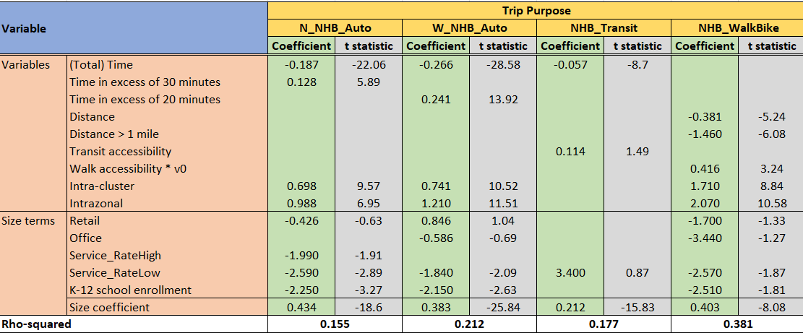
The models are sensitive to a range of network and level-of-service effects including distance and mode-specific travel times and accessibilities. Distances to potential destinations (and those over a mile) are less attractive for the walk/bike segment. Intra-cluster and intra-zonal effects are strong for auto and non-motorized modes. Walk accessibility at the destination makes destinations more desirable when there are no cars in the household. Travel time has the expected negative impact, but its impact attenuates beyond a certain threshold for the drive mode. Attractions depend on a variety of employment (retail, office, service) and school enrollment totals.

Mode Choice

W_HBW (home-based work trips along a work tour)
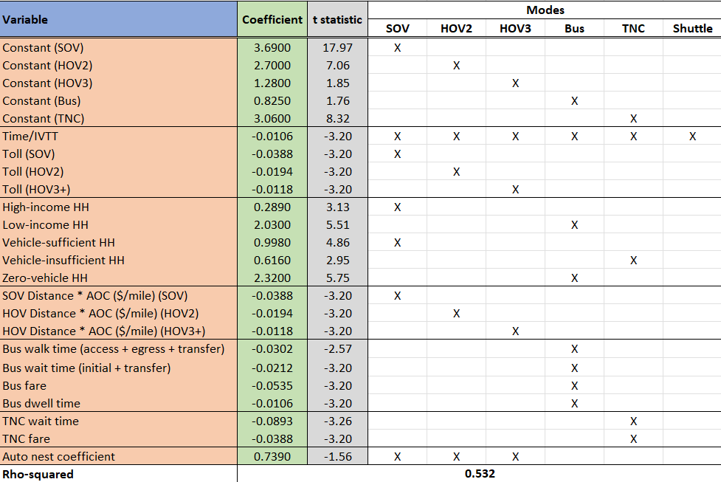
Tolls and distance have reducing negative impacts on the auto modes with increasing occupancy. High-income and vehicle-sufficient household members are more likely to drive alone, while low-income and zero-vehicle household members see a significant shift to bus. Vehicle insufficiency increases the use of TNC options. Time and fare variables have the expected negative effects.

N_HBSCH (home-based school trips along a non-work tour)
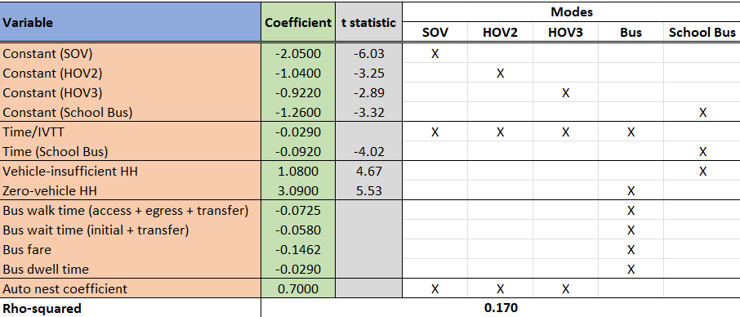
Time and fare variables have the expected negative effects. Students from vehicle-insufficient households ride the school bus more, while those from zero-vehicle households ride the bus.

N_HBSHP (home-based shop trip along a non-work tour)
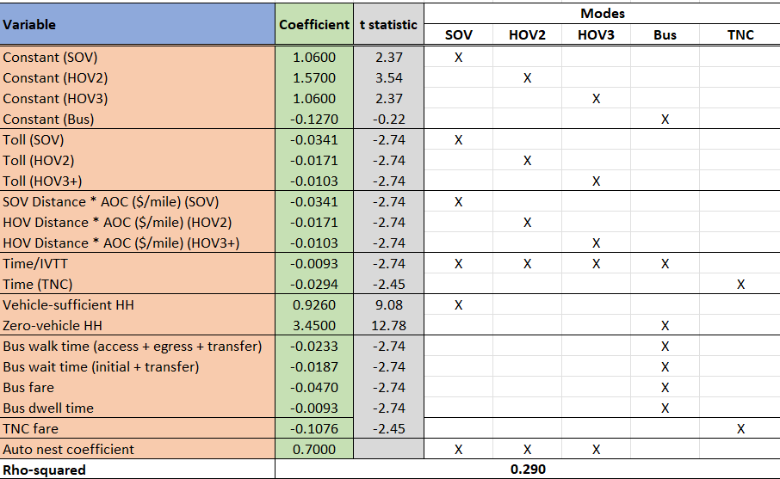
Tolls and distance have reducing negative impacts on the auto modes with increasing occupancy. Vehicle-sufficient household members are more likely to drive alone, while zero-vehicle household members see a significant propensity for bus. Time and fare variables have the expected negative effects.

N_HBSR (home-based social/recreation trip along a non-work tour)
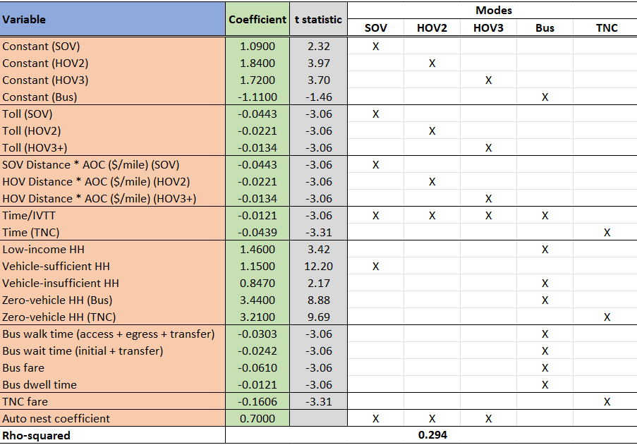
Tolls and distance have reducing negative impacts on the auto modes with increasing occupancy. Vehicle-sufficient household members are more likely to drive alone, while low-income, vehicle-insufficient and zero-vehicle household members see a significant shift to bus. The absence of vehicles in the household also increases the likelihood of TNC options. Time and fare variables have the expected negative effects.

N_HBO (home-based other trip along a non-work tour)
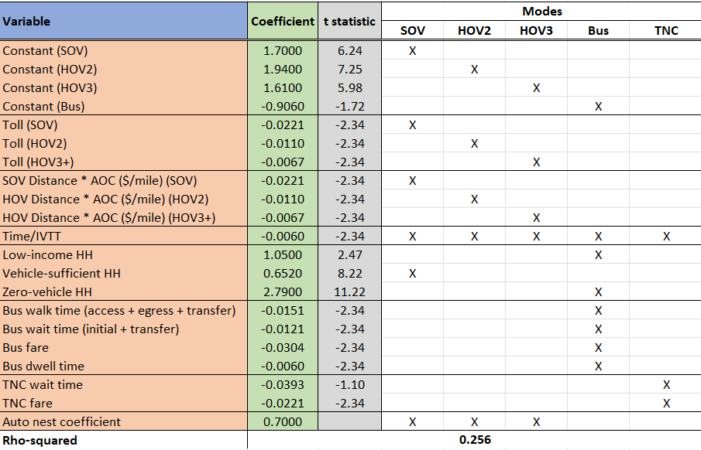
Tolls and distance have reducing negative impacts on the auto modes with increasing occupancy. Vehicle-sufficient household members are more likely to drive alone, while low-income and zero-vehicle household members see a significant shift to bus. Time and fare variables have the expected negative effects.

W_HBO (home-based other trip along a work tour)
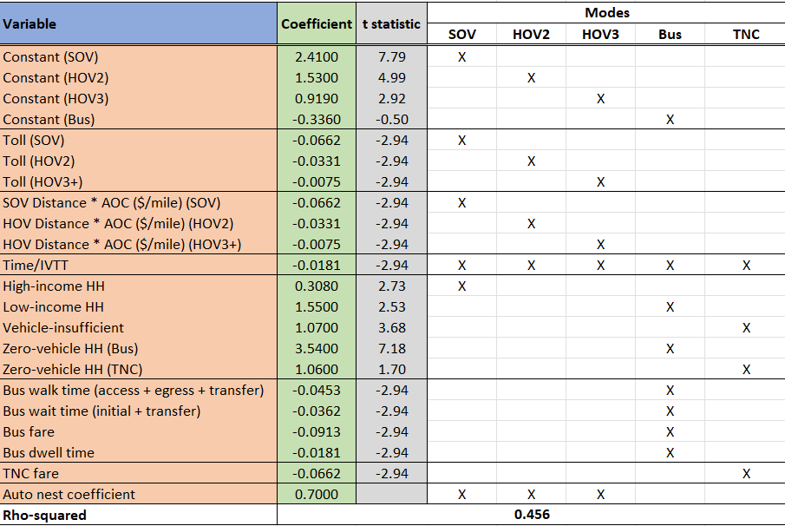
Tolls and distance have reducing negative impacts on the auto modes with increasing occupancy. High-income household members are more likely to drive alone, while low-income and zero-vehicle household members see a significant shift to bus. Vehicle insufficiency and absence of household vehicles increases the use of TNC options. Time and fare variables have the expected negative effects.
The non-home-based trip purposes have the travel mode built into them and hence do not require separate mode choice models.

Non-Home-Based
There are many problems related to non-home-based trips in traditional trip-based models arising from the fact that they are disconnected from the home-based trips with which they comprise complete tours. In order to properly represent non-home-based trips, two spatial distribution or destination/spatial choice models are required to account for both the trip’s origin location and destination location. The four-step model architecture is fundamentally flawed because it produces non-home-based trips from only one trip distribution or spatial choice model.
To address these problems, the model adopts an alternative approach with a simple change to the structure of the trip-based model, running the non-home-based model components after and conditional on the home-based model components instead of in parallel and independently of them as in the traditional four-step model. This relatively simple structural change significantly improves the model’s ability to represent non-home-based trips and their response to land use changes and transportation infrastructure investments. Running a NHB distribution or destination choice model after and conditional on home-based destination choices in this approach, provides the required second spatial distribution model to properly model both the origin and destination of NHB trips.
In this approach, NHB trips are generated separately by mode based on home-based mode choices. This essentially provides information about whether a traveler has a car with them and allows the model, despite its trip-based form, to ensure a reasonable consistency of modes on tour.
Available modes include:
- SOV
- HOV2
- HOV3+
- Auto Pay
- Transit
- Non-motorized
The model coefficients below are the result of multiple linear regression with a forced intercept at zero. In addition, the model estimation will be scaled up to a predicted regional total. As a result of these two factors, the displayed r-squared values are not as meaningful. Instead, the value of the coefficients is in determining the relative effect that various home-based trip types have on non-home-based trip generation.
When reviewing the coefficients below, note their logical consistency: SOV NHB trips are most likely to result when the HB trip is SOV or HOV. NHB walk trips can be made when a person drives from home, but is more much more likely if they walk. These results greatly improve the NHB models compared to traditional trip-based construction.
In the tables below, any “alpha” and “gamma” terms refer to boosting coefficients used. See the section on boosting for an explanation of those terms.

W_NHBO
These are non-home-based trips made on a work tour not related to work. In other words, neither end of the trip is work or home.
Interpretation of the coefficients below is complicated by two factors:
- The regression forces a y-intercept of 0.
- The NHB trips are scaled with time of day factors to match totals observed from the survey.

Given this, the interpretation of the coefficients below is limited to relative size and direction. For example, in the first model below (SOV), W_HBO_sov trips are the only trip ends that will generate W_NHBO trips. Any W_HBW_sov trips to a zone will slightly decrease the predicted W_NHBO amount because more trips from the zone will be W_NHBW.

SOV
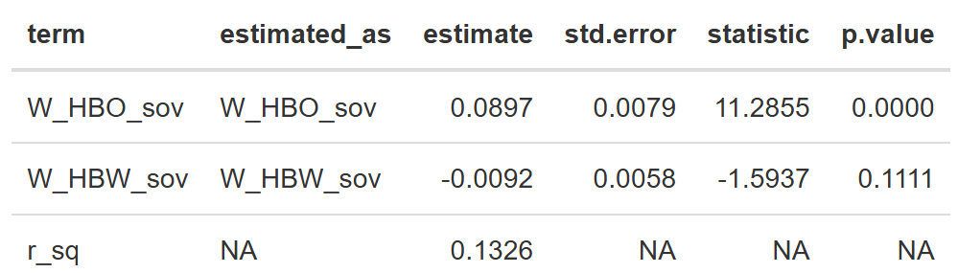

HOV2
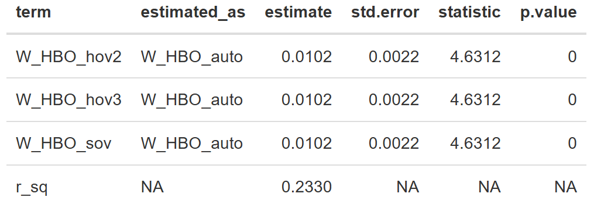

HOV3+
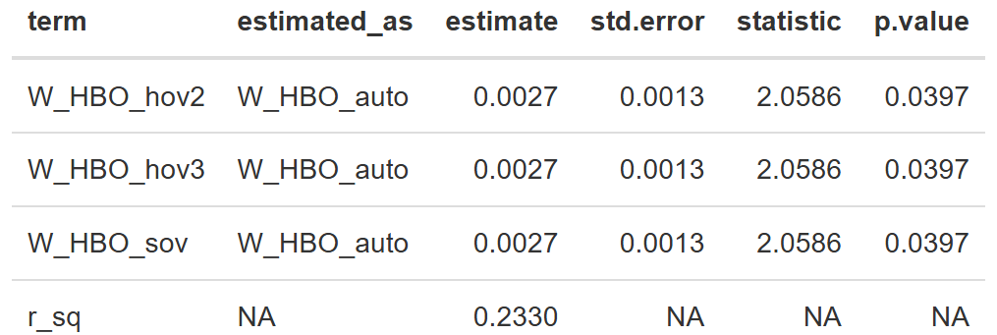

Auto Pay
No significant presence of this trip type in the survey, and it is not an important source of travel demand. No model was estimated.

Transit
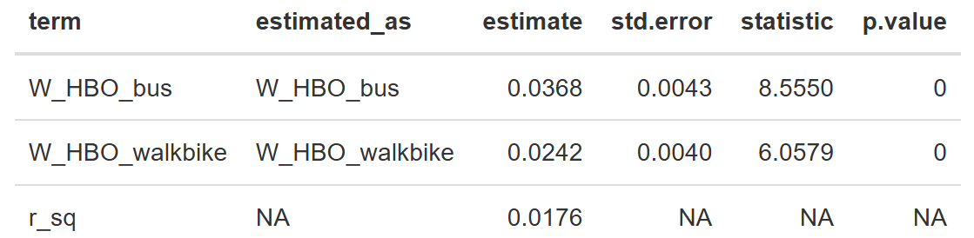

Non-motorized
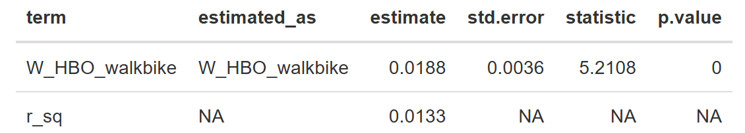

W_NHBW
These are non-home-based trips made on a work tour where one trip end is work or work-related.

SOV
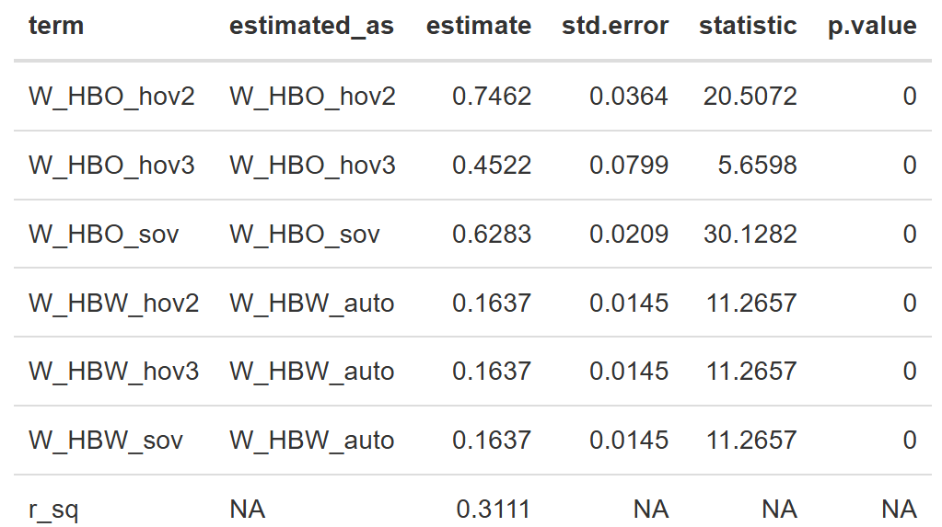

HOV2
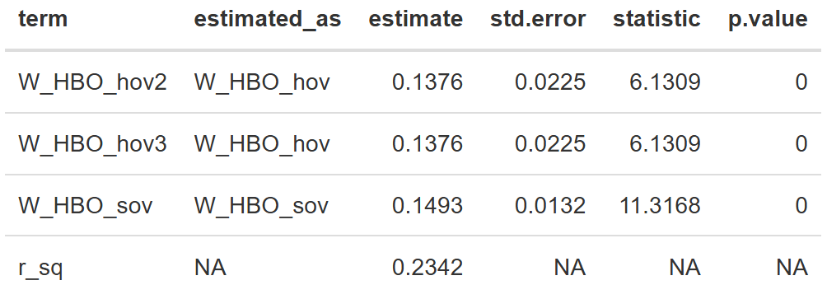

HOV3+
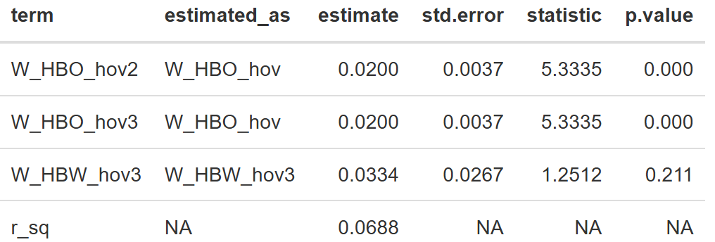

Auto Pay
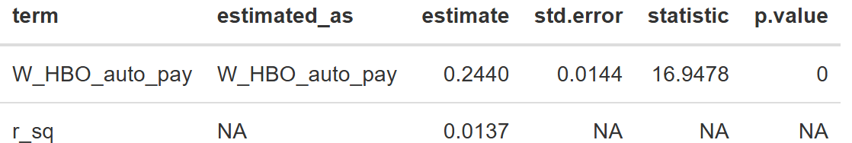

Transit
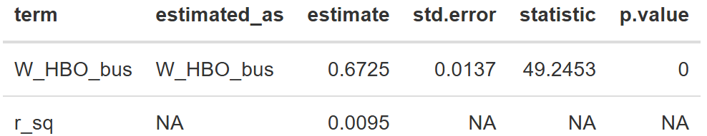

Non-motorized
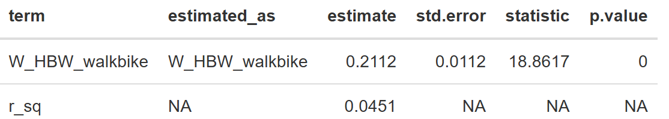

N_NHBSHP
These are non-home-based trips made on a non-work tour with one trip end for shopping.

SOV
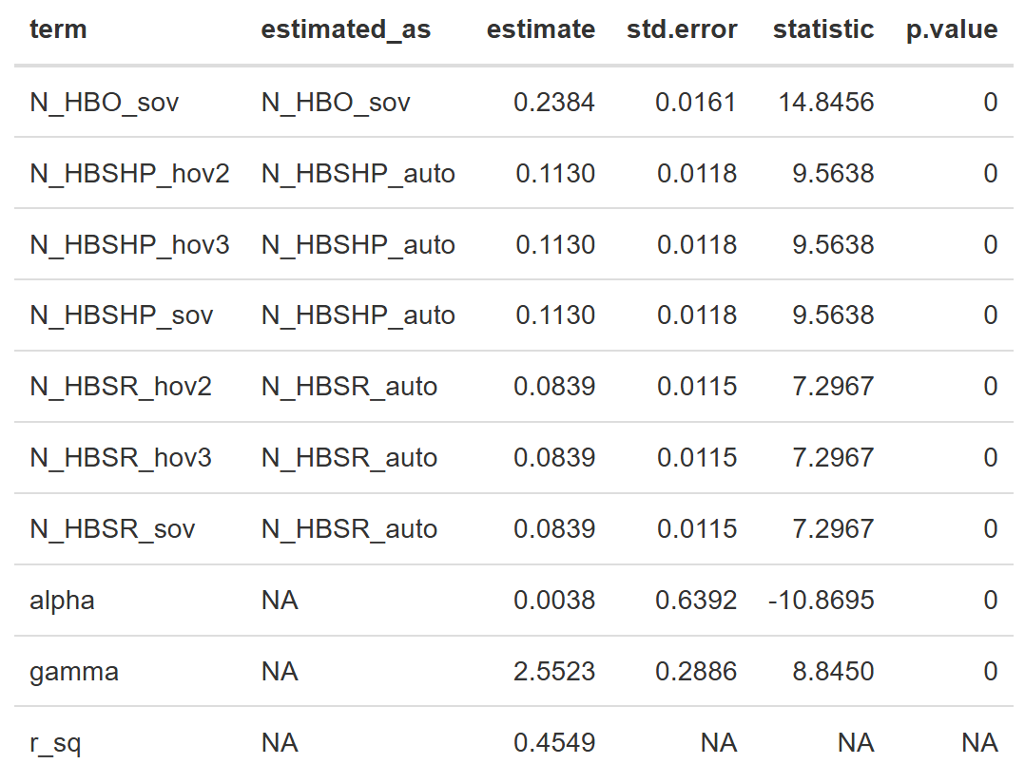

HOV2
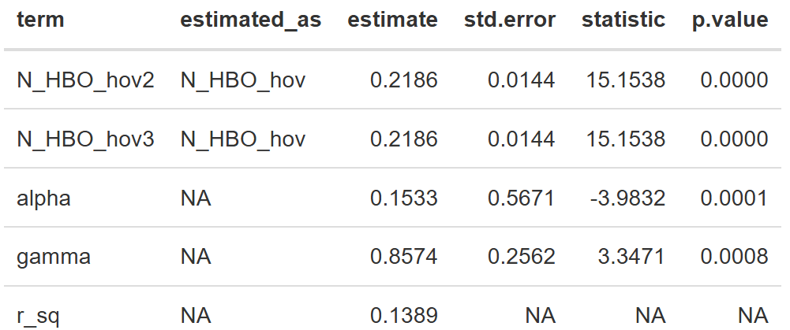

HOV3+
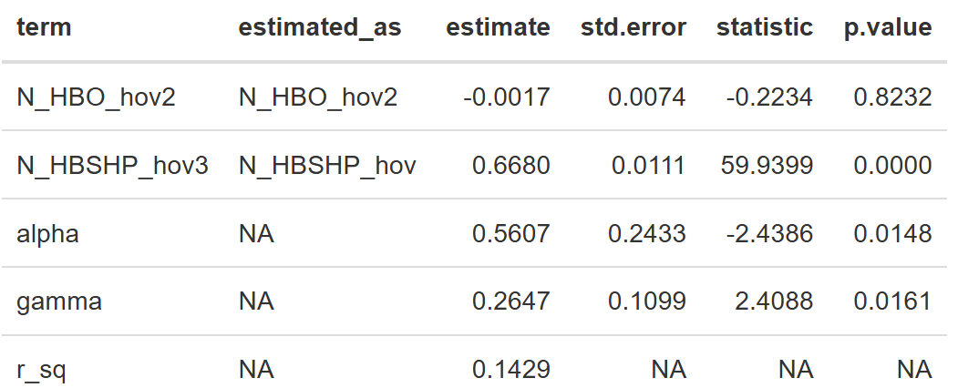

Auto Pay
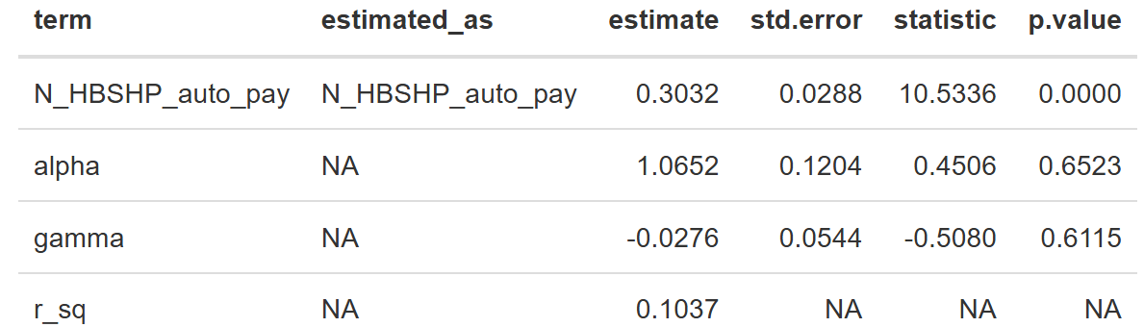

Transit
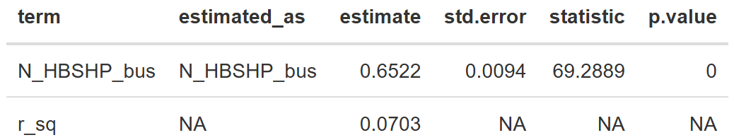

Non-motorized
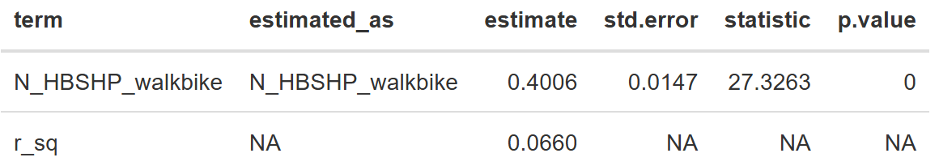

N_NHBO
These non-home-based trips are those where neither end is shopping. In effect, these are all other non-home-based trips made on non-work tours. Visiting friends or family at their home is an example of this trip type.

SOV
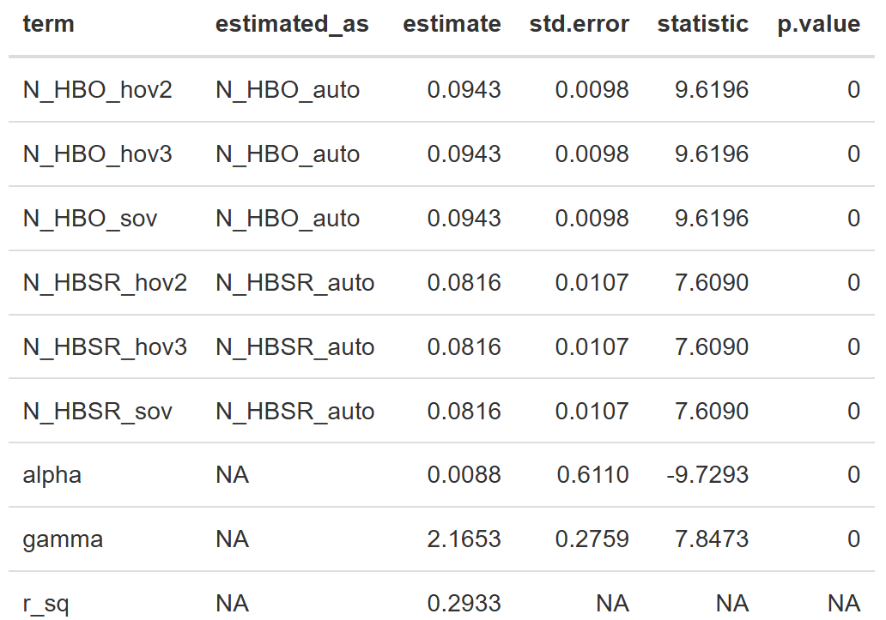

HOV2
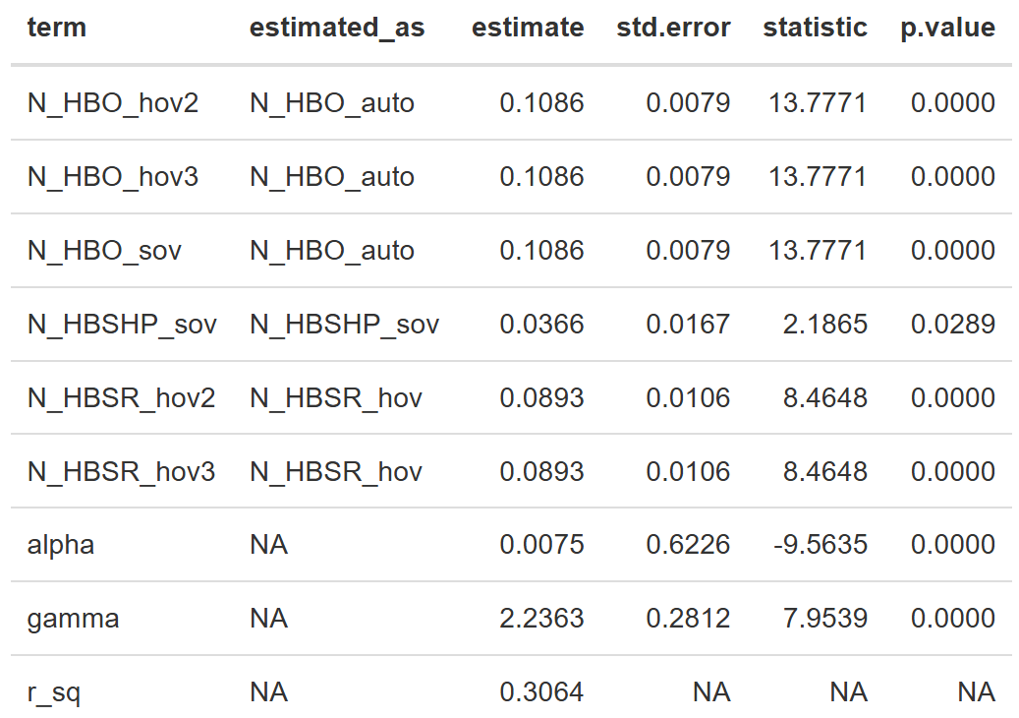

HOV3+
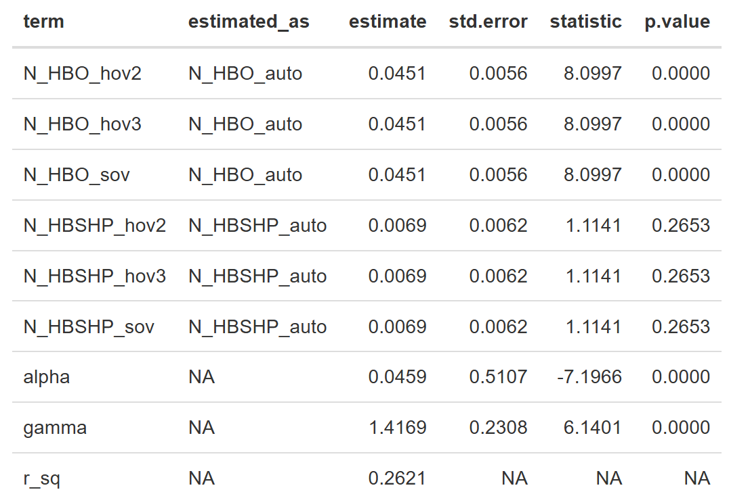

Auto Pay
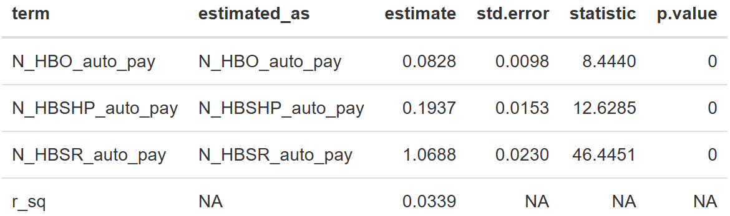

Transit
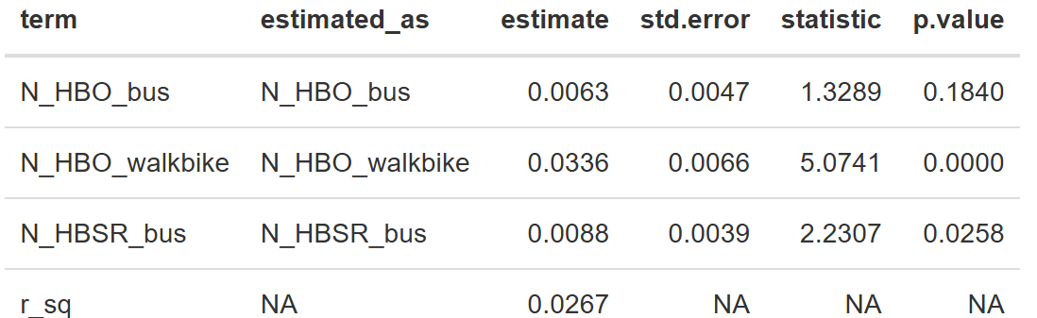

Non-motorized
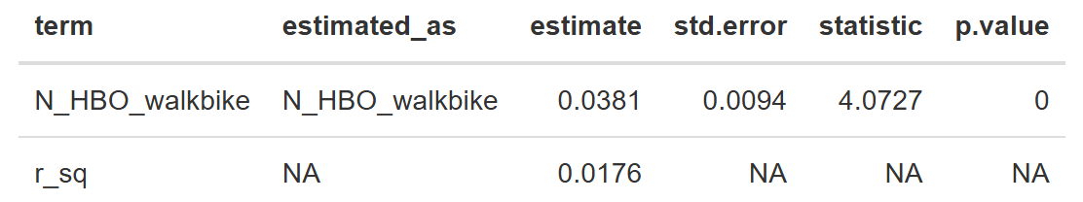

Boosting
“Boosting” is an approach borrowed from machine learning where the errors of a previous model are used to estimate a second model. The models shown above illustrate the link between home- and non-home-based trips by mode, but intuition and experience tells us that accessibility should also influence NHB trip making. Travel to a central business district is more likely to lead to further trips compared to traveling to a rural zone.
The chart below shows how accessibility impacts each trip type and mode combination. The y-axis is a simple factor. When the factor is 1, the trip rates will be the same as displayed in the tables above. A y-value of 0.5 means the trip rates will be reduced by 50 percent. Conversely, a y-value of 1.5 means that trip rates are increased by 50 percent. With this additional factor, the model will understand the role that accessibility plays in NHB trip generation.
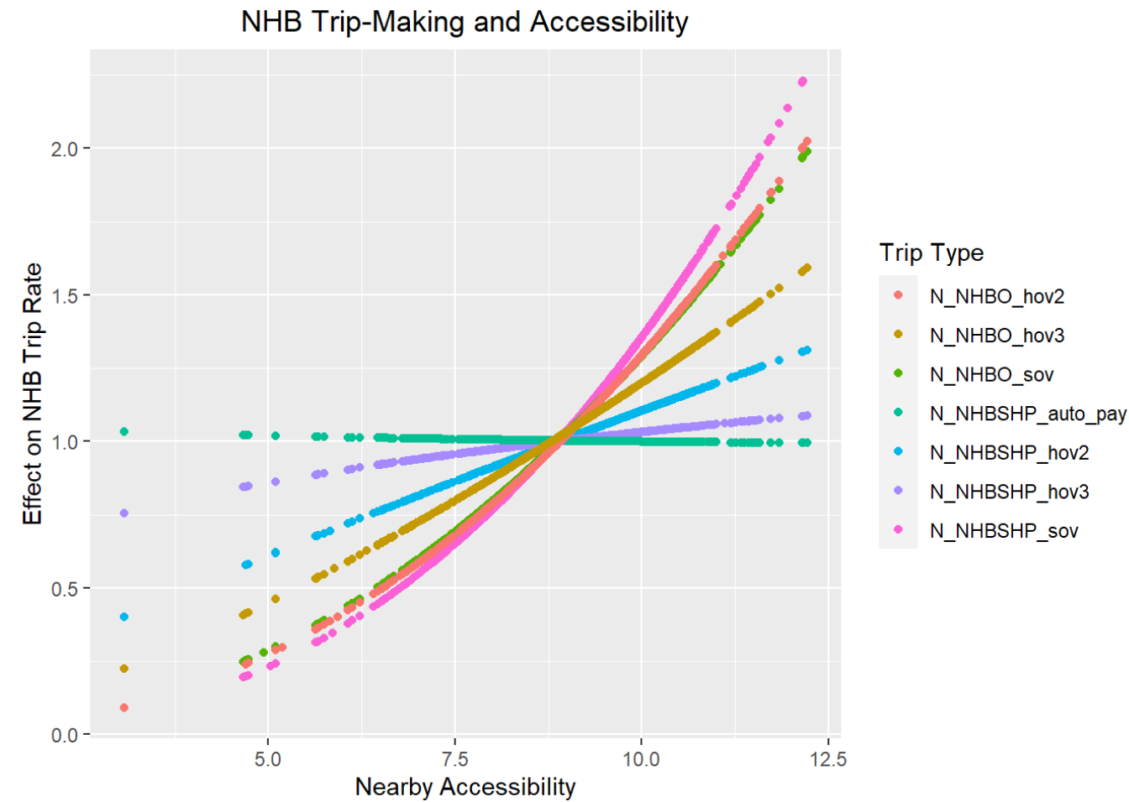

NHB Time of Day Adjustment
The independent feedback by time of day in the model presents a unique challenge for NHB. NHB and HB trips have very different time of day patterns (see Time of Day documentation), but NHB generation is simply rates multiplied by HB trip ends. Without correction, this would mean that the NHB trips would have the same distribution as HB trips. To correct this, Caliper calculated adjustment factors by tour type, mode, and time of day. This was done by comparing raw model outputs back to the observed NHB trips from the survey.
The easiest way to understand the table below is by highlighting one row as an example. For SOV trips on work tours, these factors move NHB trips out of the AM and NT periods and into the MD and PM. Another way of saying it is that, compared to HB trips, NHB trips are less likely in the AM/NT and more likely in the MD/PM. The large mid day factor reflects lunch trips and other mid-day activities. The relative size of the AM and PM periods confirms what we know: that stops are more likely to be made on the way home compared to the way to work (e.g. picking up groceries).
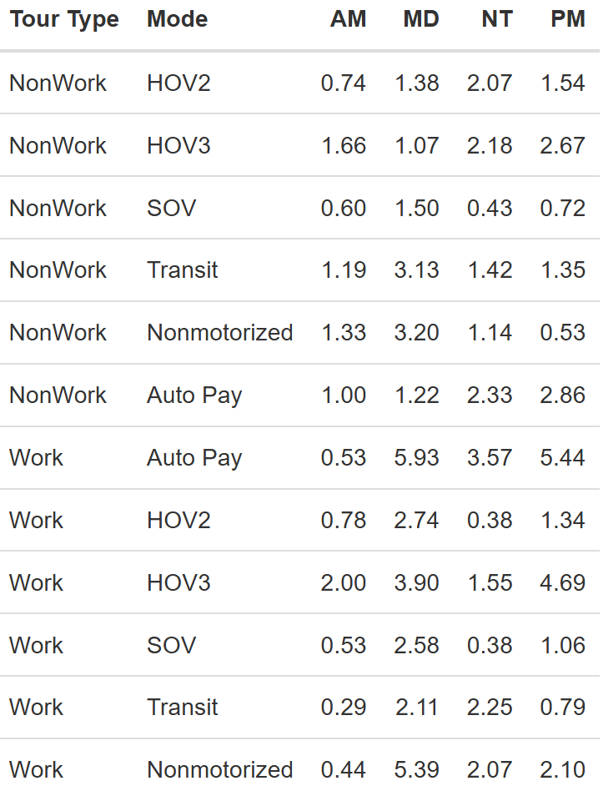

University Travel
The sub-model for university travel is important to the Reno region to capture the impact of the University of Nevada, Reno on the transportation system.
The Reno Regional University Model simulates the on- and off-campus travel of students of the region’s major university. It relies on socio-economic data inputs from the TAZ layer that designates the locations of the student population as well as the building locations on the various campuses to allocate the university trips.
For student travel, the most important distinction between students is whether they live on or off campus. On-campus students are expected to make more trips, given their ability to easily travel back and forth to their dorm/apartment rooms between classes/lunch. In addition, many of those trips are expected to start and end on campus, thus likely producing shorter trip lengths. The typical student demographic is On-campus students are more likely to be undergraduate students who are enrolled at the university full-time, with more classes. Graduate students are more likely to reside off-campus and have different travel patterns than their on-campus counterparts. Therefore, the market segmentation for the university model is stratified by on-campus and off-campus students as well as by trip purpose.
For the university model, trip generation estimates the number of university trips by market segment (on-campus and off-campus students) and purpose (6 purposes, as explained later) as a function of observed/available land use characteristics. Trip distribution uses a gravity formulation with distance as the measure of impedance and a multinomial logit mode choice model is then used to segment trips by travel mode. Time of day or “diurnal” factors are used to segment trips by time and day and convert the outcomes from production-attraction to origin-destination format. The university trips are then combined with trips from other model components prior to carrying out highway and transit assignments.
The balance of this document specifies each model component, presenting empirical evidence for each specification. As local data for the UNR student population was unavailable, coefficients are asserted, based on evidence for other travel purposes. For these asserted models, calibration targets were developed from the available university survey data in other areas and calibrated to match observed local outcomes (e.g., traffic in the vicinity of campus).

Model Segmentation
The model design reflects the desire for the university model to understand potential differences in travel for on-campus and off-campus students so that it is better able to predict behavior for individual markets than it would be for all students combined. Therefore, the model structure segments trips into the following purposes:
- Home-Based-Campus (Home-Campus or UHC): from off-campus home locations to buildings on campus or from on-campus dorms to buildings on campus
- Home-Based-Other (Home-Other or UHO): from off-campus home locations to other locations not on campus or from on-campus dorms to locations not on campus
- Campus-Based-Other (Campus-Other or UCO): from campus to locations off campus
- On-Campus (On-campus or UC1): to and from locations on the SAME campus
- University student Other-Other (Other-to-Other or UOO): from and to locations not associated to a campus
The structure segments the home-based trip purposes, Home-Campus and Home-Other, by on- and off-campus students. On-campus students are expected to make more trips, with many of those trips expected to start and end on campus. On-campus students are more likely to be undergraduate students who are enrolled at the university full-time. Graduate students are more likely to reside off-campus.
The first model step is trip generation, which estimates the number of trips by market segment and purpose as a function of observed land use characteristics. The second model step is trip distribution, which uses a common gravity formulation with distance as the measure of impedance. A multinomial logit mode choice model is then used to segment trips by travel mode. Time of day or “diurnal” factors are used to segment trips by time and day and convert the outcomes from production-attraction to origin-destination format. The university trips are then combined with trips from other model components prior to carrying out roadway and transit assignment.
An innovative feature of the model design is the generation step for the Other-to-Other trip purpose. To maintain consistency across travel model, these trips are generated directly from the Home-based Other and Campus-based Other trip ends. The generation step is mode specific. For example, if all the Home-based Other and Campus-based Other trips select automobile, then only automobile Other-to-Other trips will be generated.

University Trip Productions
The selected production rates for four of the five trip types or purposes (all except Other-to-other) are presented in the table below. For home-based trip purposes, separate rates are presented based on student home location (on- or off-campus). The production rates for home-based trips are trips per student. For campus-based trips, the production rates are per 1000 square feet of campus building space.
Home Location | Trip Purpose | Production Rate | Unit
On-campus | Home-Campus | 1.08 | Student
On-campus | Home-Other | 1.54 | Student
Off-campus | Home-Campus | 0.23 | Student
Off-campus | Home-Other | 1.12 | Student
All-Students | On-campus | 10.05 | Campus Building SF (in 000s)
All-Students | Campus-Other | 3.60 | Campus Building SF (in 000s)
Trip production rates by mode were used to estimate productions for Other-to-other trips. More specifically, the Other-to-other productions, as described previously, were a function of Home-based Other and Campus-to-Other attractions. Like the resident models, this approach ensures consistency between the “Other” trip ends by mode, i.e., it is not possible to have only automobile Home-Other and Campus-Other movements and only bicycle Other-to-other movements. The choice to generate trips by mode for this purpose was driven by the desire to maintain model consistency with tours.
The table below summarizes the Home-Other and Campus-Other trips by mode: (1) Auto, which includes both drive and carpool; (2) Transit; (3) Walk; and (4) Bicycle.
Trip Purpose | Mode | Trip Rate
Home-Other and Campus-Other | Auto | 0.283
Home-Other and Campus-Other | Walk | 0.003
Home-Other and Campus-Other | Transit | 0.013
Home-Other and Campus-Other | Bicycle | 0.024

University Trip Attractions
Trip attraction rates for off-campus attractions (Home-Other and Campus-Other) are applied to zonal characteristics including the off-campus student population and the number of retail jobs. Home-Other attractions are estimated separately for on-campus and off-campus students.
variable | Home-Other On-Campus | Home-Other Off-Campus | Campus-Other
intercept | 5.5856 | 100.1907 | 73.7073
retail_employment | 0.0247 | 0.0394 | 0.0563
student_off_campus | 0.0292 | 0.224 | 0.4086

For on-campus attractions (Home-based Campus, Campus-to-campus), the attractions are distributed among campus zones proportional to the distribution of the square footage of university buildings.

University Trip Distribution
The second step of the University Model development process is to develop a trip distribution model. In this step, the TAZ level productions and attractions estimated in the trip generation step are allocated to TAZ pairs. The allocation is based on a gravity model that takes into account the distance between each of the TAZ pairs.
A distance-based gravity model is used to distribute the university trips from production zones to attraction zones. It was assumed that the friction factors are a function of distance (along the roadway network) and that they follow a gamma distribution, as below:
Purpose | a | b | c
Home-Campus - Off-campus students | 5 | 0.8 | 0.1
Home-Other- Off-campus students | 5 | 0.9 | 0.1
All other | 5 | 1.1 | 0.1

University Mode Choice
The third step in the University Model development process is the mode choice model. During the mode choice step, trips by zonal pair are distributed across available modes. A multinomial mode choice model was used to split trips between the University Model’s four modes - walk, bike, transit and car based on time, cost and modal preferences. The model assumed a very simple utility function based only on the in-vehicle and out-of-vehicle travel times by mode and the cost of each mode (if any). The same parameters were used for all home- and campus-based trips, although asserted constants were used to vary mode split by purpose.
Coefficient | Value
IVTT | -0.02
OVTT | -0.03
Cost | -0.20

University Time-of-Day
The fixed factors shown below were applied to split out university trips by purpose into the model’s time-of-day periods.
 | Home-Campus | Home-Other | Campus- Other | On-Campus
AM | 0.1000 | 0.1213 | 0.1343 | 0.1276
MD | 0.4975 | 0.4332 | 0.5983 | 0.6688
PM | 0.1858 | 0.1970 | 0.2674 | 0.2036
NT | 0.2167 | 0.2485 | 0.0000 | 0.0000

External Travel

Introduction
Travel from outside the Reno regional model’s geographic boundary to locations inside the boundary are referred to as “external-internal” or “EI” trips. Movements from inside the boundary to outside are “internal-external” or “EI” trips. Movements through but not stopping within the region are referred to as “external-external” or “EE” trips. Together, these travel patterns are referred to here as “EE” and “IE/EI” travel. This document discusses the development of these components of the regional model.
Base year auto external travel patterns were developed from Caliper’s Transography data, drawing on connected vehicle data from April of 2022. A total of 119,559 external trips were observed in the data, of which 3,970 were through trips and 115,589 were inbound/outbound trips.

External-External (Through) Trips
External-external or through trips are estimated by applying iterative proportional fitting (also known as raking or the RAS algorithm and sometimes mistakenly identified with the similar Fratar process) to grow the estimated base year external-external (“seed”) matrix to estimated future marginal sums (the total trips to/from each station).
The base year auto and truck matrices are shown below.
 | 3001 | 3002 | 3003 | 3004 | 3005 | 3006 | 3007 | 3008 | 3009 | 3010 | 3011 | 3012
3001 | 0.0 | 17.7 | 39.0 | 3.7 | 0.0 | 207.6 | 68.8 | 1.4 | 34.8 | 6.7 | 402.2 | 1.6
3002 | 14.3 | 0.0 | 1.2 | 0.0 | 0.0 | 4.4 | 7.0 | 0.0 | 4.1 | 1.1 | 54.9 | 1.1
3003 | 29.2 | 0.8 | 0.0 | 0.3 | 0.0 | 3.4 | 33.8 | 3.4 | 27.5 | 3.5 | 178.2 | 1.6
3004 | 8.0 | 0.0 | 0.0 | 0.0 | 0.0 | 0.0 | 0.0 | 0.0 | 0.0 | 0.0 | 7.4 | 0.0
3005 | 0.0 | 0.0 | 0.0 | 0.0 | 0.0 | 4.9 | 13.7 | 11.2 | 0.0 | 0.0 | 0.0 | 0.0
3006 | 150.6 | 3.1 | 5.4 | 0.0 | 3.1 | 0.0 | 13.1 | 146.4 | 1.8 | 0.7 | 45.5 | 5.4
3007 | 103.2 | 12.2 | 29.8 | 0.0 | 16.9 | 9.3 | 0.0 | 2.2 | 0.0 | 0.0 | 7.4 | 0.0
3008 | 0.0 | 0.0 | 1.1 | 0.0 | 12.1 | 181.1 | 13.3 | 0.0 | 0.0 | 0.0 | 0.0 | 0.0
3009 | 34.1 | 4.8 | 17.0 | 0.0 | 0.0 | 3.4 | 1.0 | 0.0 | 0.0 | 0.0 | 0.0 | 0.0
3010 | 9.4 | 1.7 | 8.5 | 0.0 | 0.0 | 0.0 | 0.0 | 0.0 | 0.0 | 0.0 | 9.0 | 9.0
3011 | 377.9 | 46.4 | 184.6 | 2.1 | 0.0 | 85.4 | 12.2 | 2.5 | 2.2 | 15.7 | 0.0 | 25.6
3012 | 4.1 | 0.0 | 2.5 | 0.0 | 0.0 | 0.0 | 0.0 | 0.0 | 0.0 | 18.7 | 20.2 | 0.0
Figure 6. Base Year (2022) Auto External-External Trips
 | 3001 | 3002 | 3003 | 3004 | 3005 | 3006 | 3007 | 3008 | 3009 | 3010 | 3011 | 3012
3001 | 0.0 | 0.0 | 0.0 | 1.9 | 0.0 | 258.4 | 0.0 | 0.0 | 0.0 | 0.0 | 0.0 | 0.0
3002 | 0.0 | 0.0 | 0.0 | 0.0 | 0.0 | 5.9 | 0.0 | 0.0 | 0.0 | 0.0 | 0.0 | 0.0
3003 | 0.0 | 0.0 | 0.0 | 1.8 | 0.0 | 43.4 | 0.0 | 0.0 | 0.0 | 0.0 | 0.0 | 0.0
3004 | 8.1 | 0.0 | 0.0 | 0.0 | 0.0 | 0.0 | 0.0 | 0.0 | 0.0 | 0.0 | 2.1 | 0.0
3005 | 0.0 | 0.0 | 0.0 | 0.0 | 0.0 | 5.9 | 0.0 | 0.0 | 0.0 | 0.0 | 0.0 | 0.0
3006 | 196.4 | 4.7 | 35.7 | 0.0 | 5.4 | 0.0 | 17.0 | 18.4 | 6.4 | 5.1 | 16.7 | 0.4
3007 | 0.0 | 0.0 | 0.0 | 0.0 | 0.0 | 22.3 | 0.0 | 0.0 | 0.0 | 0.0 | 0.0 | 0.0
3008 | 0.0 | 0.0 | 0.0 | 0.0 | 0.0 | 27.1 | 0.0 | 0.0 | 0.0 | 0.0 | 0.0 | 0.0
3009 | 0.0 | 0.0 | 0.0 | 0.0 | 0.0 | 6.5 | 0.0 | 0.0 | 0.0 | 0.0 | 0.0 | 0.0
3010 | 0.8 | 0.2 | 3.5 | 0.0 | 0.0 | 0.0 | 0.0 | 0.0 | 0.0 | 0.0 | 0.2 | 0.0
3011 | 0.0 | 0.0 | 0.0 | 0.2 | 0.0 | 23.2 | 0.0 | 0.0 | 0.0 | 0.0 | 0.0 | 0.0
3012 | 0.0 | 0.0 | 0.0 | 0.0 | 0.0 | 0.0 | 0.0 | 0.0 | 0.0 | 0.4 | 0.0 | 0.0
Figure 7. Base Year (2022) Truck External-External Trips
The total external-external trips by station for autos and trucks for a given scenario are given by simply apply the percent auto EE and percent truck EE to the total external station volume provided by the user in the SE data file. The base year data is provided below:
Station | AWDT | % Auto EE | % Auto IEEI | % Trk EE | % Trk IEEI
3001 | 32000 | 4.7 | 72.4 | 1.5 | 21.4
3002 | 4600 | 3.8 | 90.6 | 0.2 | 5.4
3003 | 6300 | 9.1 | 78.4 | 1.3 | 11.2
3004 | 870 | 2.5 | 57.3 | 1.6 | 38.6
3005 | 1250 | 5.0 | 80.0 | 0.9 | 14.1
3006 | 9400 | 9.3 | 45.5 | 7.5 | 37.7
3007 | 11550 | 3.0 | 87.1 | 0.3 | 9.6
3008 | 4350 | 8.6 | 80.9 | 1.0 | 9.4
3009 | 5100 | 2.6 | 88.7 | 0.3 | 8.5
3010 | 2450 | 3.4 | 85.5 | 0.4 | 10.7
3011 | 44000 | 3.4 | 93.9 | 0.1 | 2.6
3012 | 5350 | 1.7 | 97.3 | 0.0 | 1.0

External-Internal / Internal-External (Inbound/Outbound) Trips
The number of IE/EI trips are controlled by the volumes at the external station after external travel has been subtracted (using the table above). These trips are distributed to internal zones using a gravity model. The number of trips at each external station are treated as the productions. The attractions at each internal zone are estimated as a simple function of the zone’s population and employment:
$$Inbound\text{/}Outbound Attractions =0.1551×Population+0.0059×Employment$$
The gravity model uses a gamma function for the friction factors with parameters varying based on the type of external station as categorized by the average length of trip it serves.
Type | a | b | c
Long | 5 | 0.25 | 0.1
Medium | 5 | 0.6 | 0.1
Short | 5 | 1.3 | 0.1
The external stations were categorized as follows:
Station | Type
3001 | Medium
3002 | Medium
3003 | Long
3004 | Medium
3005 | Medium
3006 | Long
3007 | Short
3008 | Medium
3009 | Medium
3010 | Medium
3011 | Long
3012 | Medium

External Trip Time-of-Day
The fixed factors shown below were applied to split out external trips into the model’s time-of-day periods:
Period | EE Auto | EE Truck | EI/IE
AM | 11.80% | 15.50% | 12.72%
MD | 48.06% | 46.30% | 40.46%
PM | 18.84% | 14.05% | 22.71%
NT | 21.30% | 24.15% | 24.12%

Trucks and Commercial Vehicle Travel

Introduction
Trucks and commercial vehicles contribute significantly to congestion on major facilities in an urban area. In most instances, their travel behavior is distinct from residents of that urban area. To better capture commercial vehicle traffic in the Reno regional model, a separate set of commercial vehicle models were developed. These include trip generation, time of day, and distribution for three commercial vehicle types: commercial autos, vans, and pickups (CV), single unit trucks (SUT), and multi-unit trucks (MUT).
These classes are defined using the federal vehicle classification.
- CV - Classes 1-3
- SUT - Classes 5-7
- MUT - Classes 8-13
The models use the Quick Response Freight Manual (QRFM) approach, re-calibrated based on local truck count data.

Truck Trip Generation
Truck trip generation uses a collapsed set of employment by industry variables. The rates in the table below are applied to the employment in each category to generate truck trips.
Field | CV | SUT | MUT
Industry | 0.870 | 0.226 | 0.100
Retail | 0.774 | 0.220 | 0.048
Office | 0.383 | 0.059 | 0.007
Service_RateLow | 0.383 | 0.059 | 0.007
Service_RateHigh | 0.383 | 0.059 | 0.007
HH | 0.218 | 0.086 | 0.028

Truck Trip Distribution
Once generated, commercial vehicle and truck trips are distributed among zones using a gravity model. The gravity model uses a gamma function for the friction factors with parameters varying by truck type.
 | a | b | c
CV | 5 | 1 | 0.1
SUT | 5 | 0.75 | 0.1
MUT | 5 | 0.6 | 0.1

Truck Time-of-Day
The fixed factors shown below were applied to split out truck and commercial vehicle trips into the model’s time-of-day periods:
 | CV | SUT | MUT
AM | 0.091 | 0.097 | 0.106
MD | 0.452 | 0.393 | 0.444
PM | 0.125 | 0.133 | 0.145
NT | 0.331 | 0.378 | 0.306

Airport Model
The airport model was borrowed from the Triangle Regional Model (Raleigh/Durham, NC). Survey data for Reno would need to be collected before this model could be updated. The model uses the number of daily enplanements (specified in the socio-economic data) and runs a simple destination choice. It then applies time of day and directionality factors.

Destination Choice
The destination choice model is simple. Since the airport is a single zone, that is considered the production end and attraction zones are all other zones in the model. The model uses:

- Total employment
- High-paying jobs
- High-paying jobs interacted with distance from the airport
- Workers in the zone

Variable | Coefficient
employment | 0.0148
high_paying_jobs | 0.0479
high_paying_jobs_distance | -0.0037
workers | 0.0281

Time of Day
The time-of-day factors for airport trips are given below.

Period | Factor
AM | 0.0895
MD | 0.3735
PM | 0.175
NT | 0.362

Directionality
The directionality factors convert from PA to OD format to capture the true direction of travel by time period. For example, in the AM period, most travel is towards the airport.
Period | PA Factor
AM | 0.631285
MD | 0.504685
PM | 0.442857
NT | 0.490331

Validation
Once the behavioral models were estimated and calibrated using survey data, Caliper ran the full model and compared outputs to traffic counts (2022 counts). This data provided a check on model performance in the base year and built confidence that the model can be used in the future.
The table below presents the percent difference and percent root mean square error, which are measures of how well the model matches counts in aggregate. The table further breaks down this metric by volume group. The model matches count closely both overall and by volume group. Some general rules of thumb:
- Overall percent difference between model and counts should be +/- 5%
- Overall %RMSE should be between 30-40%
- %RMSE should be smaller for larger volume facilities
Volume Group | N | Total Count | Total Volume | % Difference | %RMSE
10000 | 517 | 2052000 | 2147510 | 4.65 | 69.33
25000 | 199 | 3160300 | 3152887 | -0.23 | 38.24
50000 | 57 | 1908600 | 1912780 | 0.22 | 18.69
100000 | 17 | 1199900 | 1285451 | 7.13 | 13.96
100000+ | 11 | 1509300 | 1527212 | 1.19 | 8.19
All | 801 | 9830100 | 10025839 | 1.99 | 37.01

The second table presents the same metrics by HCM type. The model uses independent capacities for each of these roadway types, and this table makes sure each is performing well. Major collectors show large metrics, but with only two counts, this is not cause for concern.
HCM Type | N | Total Count | Total Volume | % Difference | %RMSE
Arterial | 235 | 1865100 | 1807053 | -3.11 | 48.98
Collector | 109 | 276800 | 210763 | -23.86 | 86.79
Freeway | 252 | 4543800 | 4885856 | 7.53 | 25.41
Local | 30 | 56600 | 61305 | 8.31 | 94.52
MajorArterial | 173 | 3087000 | 3059609 | -0.89 | 35.8
MajorCollector | 2 | 800 | 1253 | 56.62 | 148.27
All | 801 | 9830100 | 10025839 | 1.99 | 37.01

In addition to aggregate checks, Caliper performed link-level validation using maps like the one shown below. In this map, red colors show where the model is higher than counts while blue show where it is lower. Green indicates that the deviation is within the maximum desirable deviation range. No model with useful sensitivity will achieve a green color for all links. These maps guide the review process by showing where errors are largest and suggesting the presence of network or other errors.
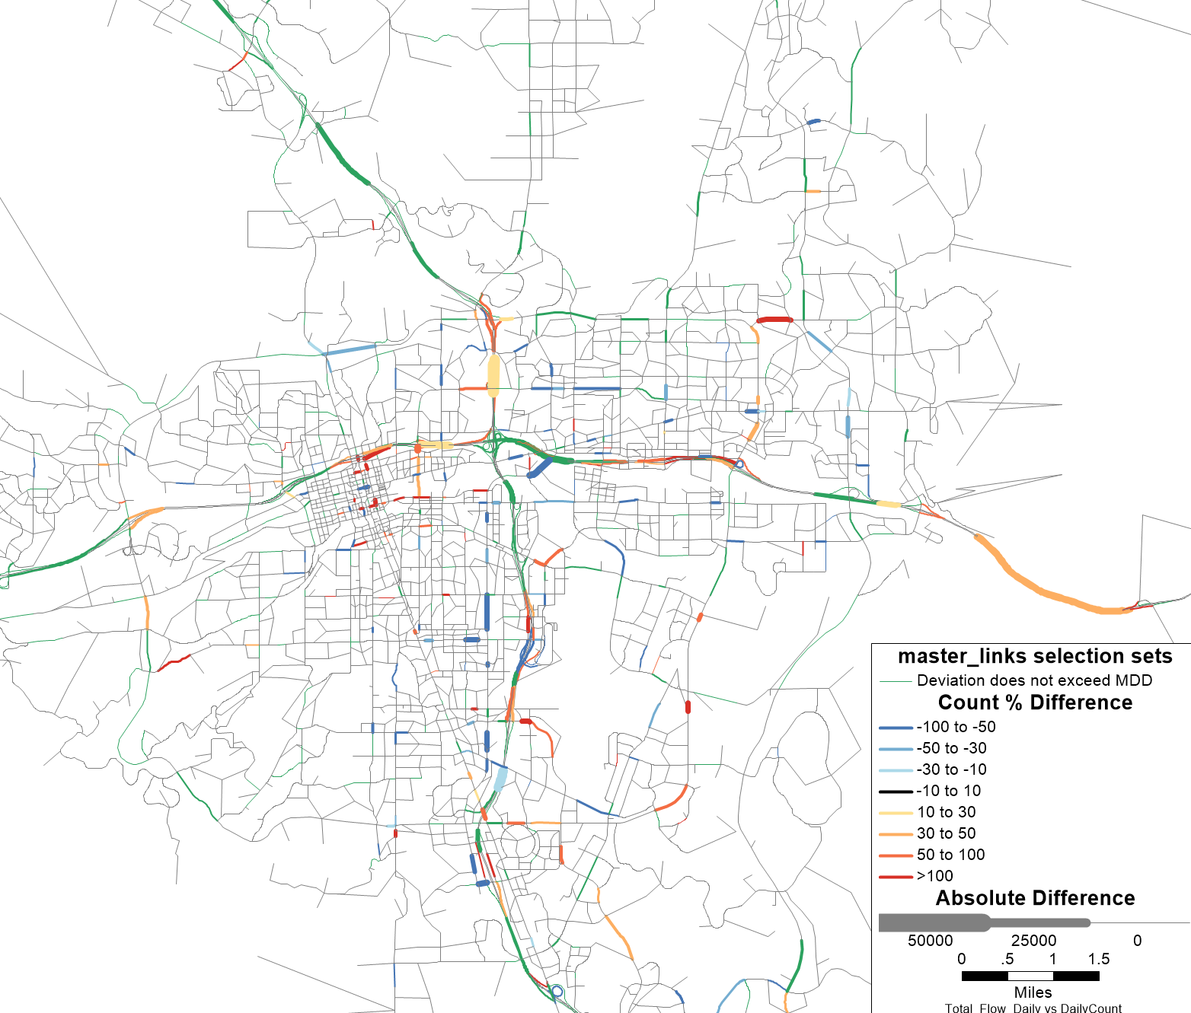

Transit
Transit validation is done by checking total transit ridership to observed boardings and alightings. The table below shows unlinked trips (total boardings) for both model and observed. The observed boardings come from the 2024 APTA report.
Model: 18,490
Observed: 17,700
The model accurately predicts the aggregate level of transit usage.

